# Operators, Conditional Statements, Loops, Functions, Arrays, Pointers and Structures

## OBJECT ORIENTED PROGRAMMING LAB



**ASSIGNMENT #01**

Submitted By:

### Qasim Ali

(20P-0070)

Submitted to:

### MR. MUHAMMAD ABDULLAH ORAKZAI

(COMPUTER INSTRUCTOR)

## DEPARTMENT OF COMPUTER SCIENCE FAST NATIONAL UNIVERSITY OF COMPUTER AND EMERGING SCIENCES, PESHAWAR

**Session 2020-2024**

**ASSIGNMENT #01**

**Operators, Conditional Statements, Loops, Functions, Arrays, Pointers and Structures Object Oriented Programming – Lab**

**Operators**

**Qno1:**

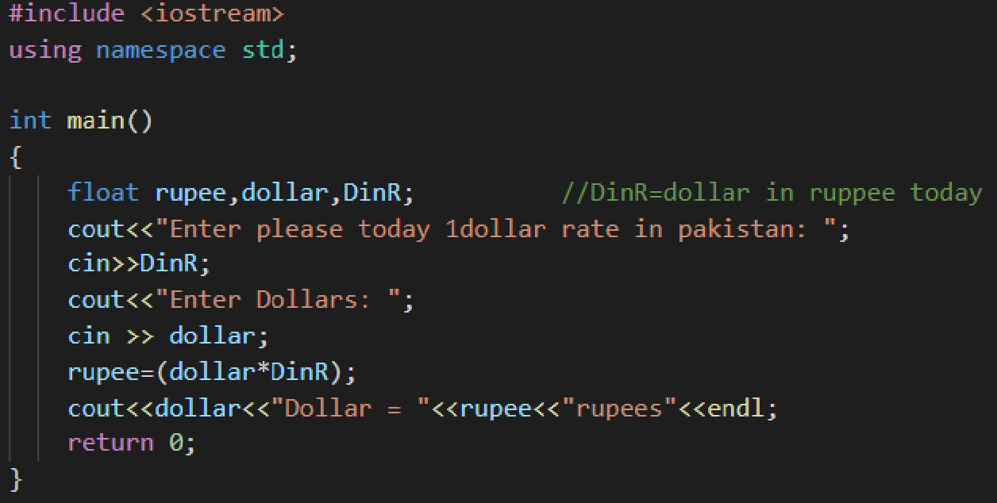

Write C++ program that will convert dollar to rupees(Dollar to Rupees Conversing Calculator).

**Output**

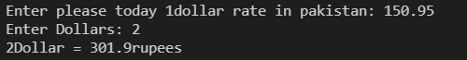

**Qno2**

Write C++ program that will convert rupees to dollar (Rupees to Dollar Conversion Calculator).

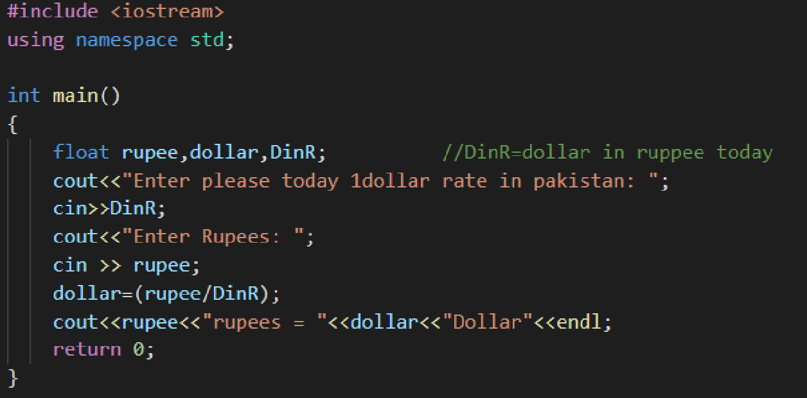

**OUTPUT**

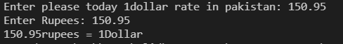

**QNO3**

Write a C++ program that will convert centigrade to Fahrenheit.

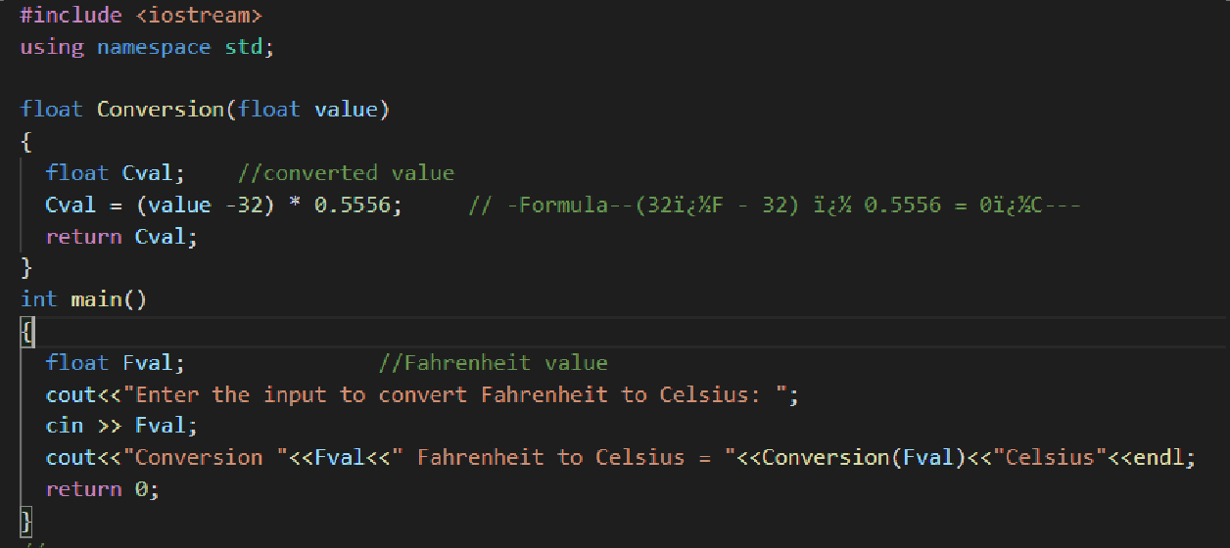

Output:-

## 

## QNO4

Take student name and marks of your 2nd semester from user and then generate DMC which will contain obtained marks out of total and percentage.

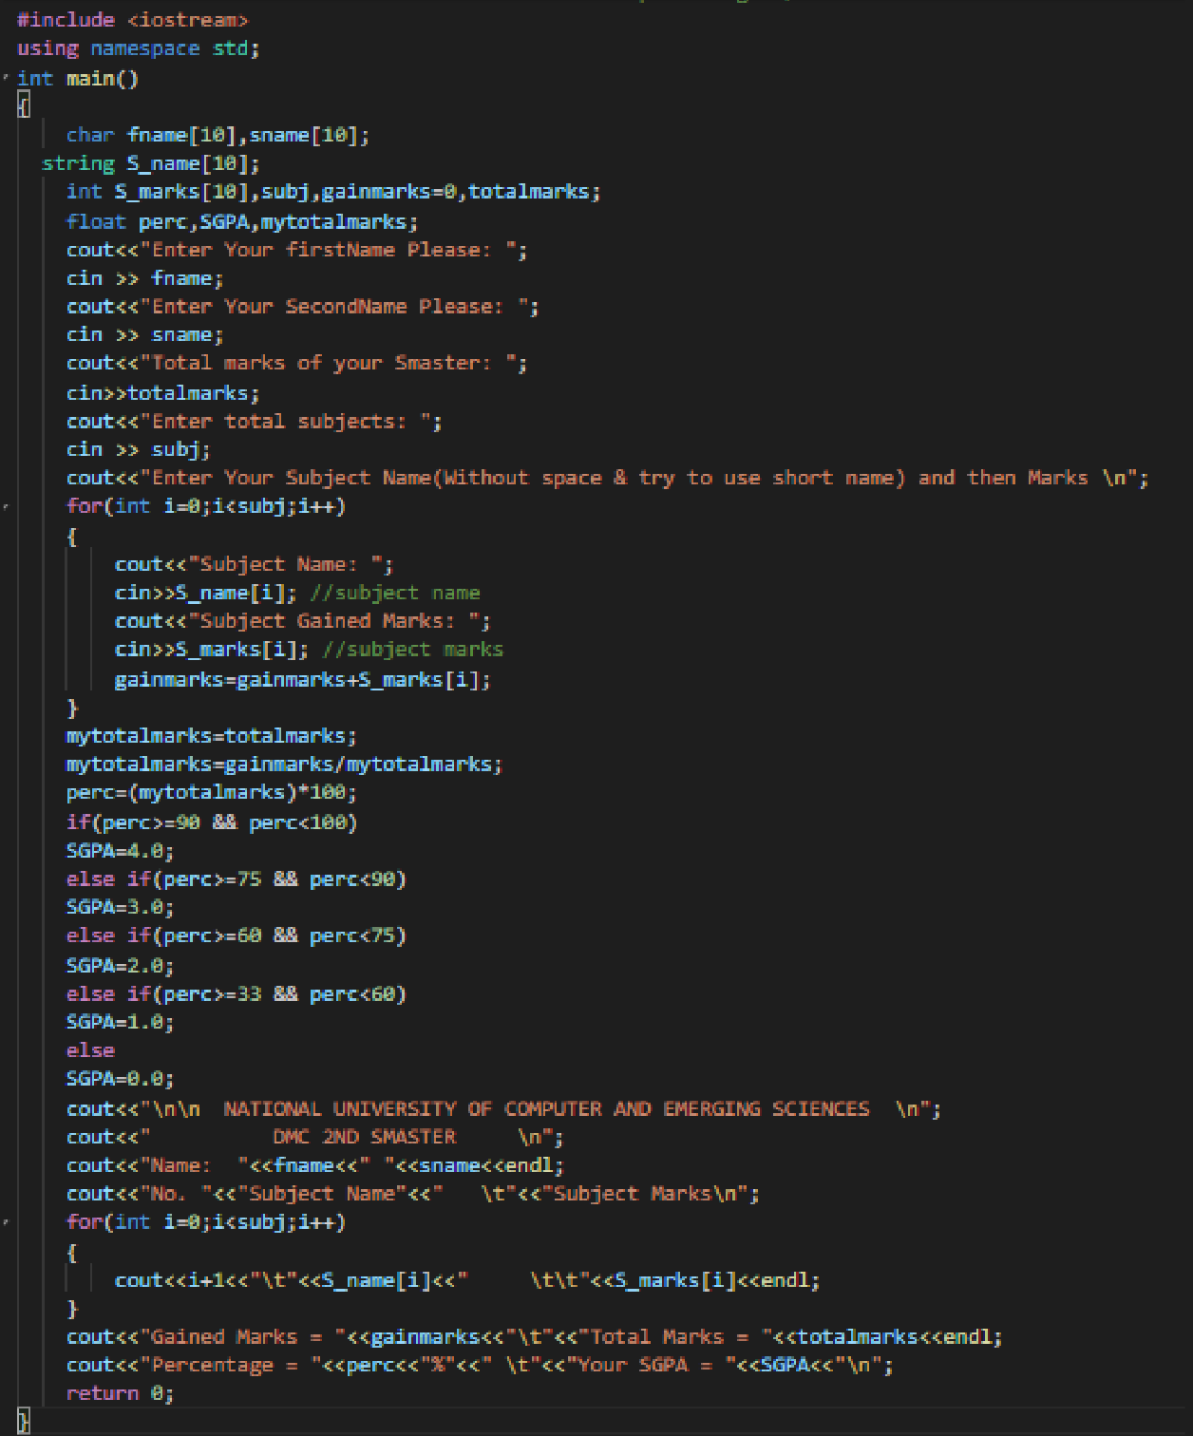

**OUTPUT:**

Qasim

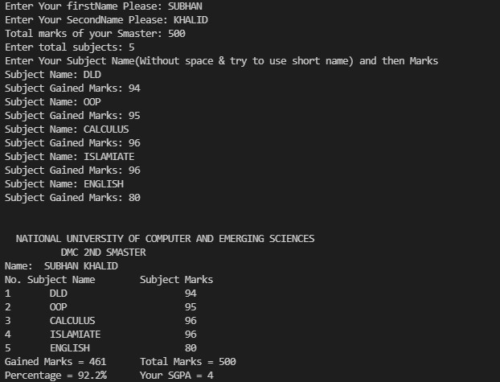

Qasim Ali

Qasim

Ali

Q NO #05:-In lab manual 2.3 math functions (Other Math Functions) are listed in the form of table

you all are directed to implement all these functions using C++ program.

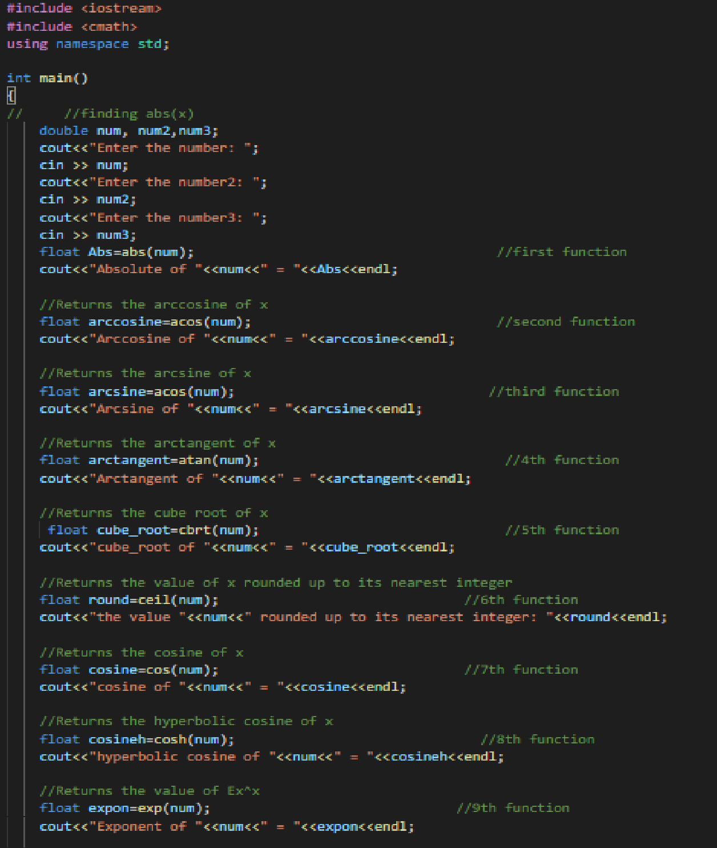

**Its next part is below for complete function**

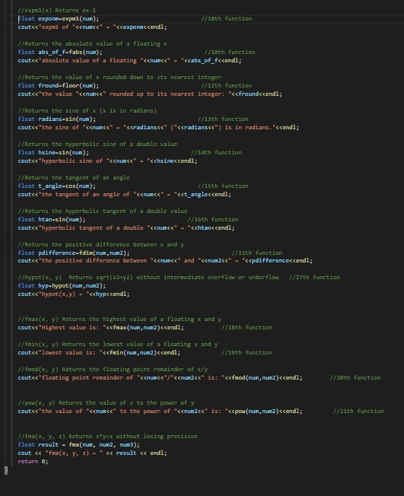

**OUTPUT :**

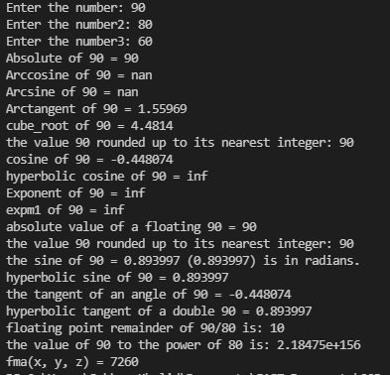

**Conditional Statements**

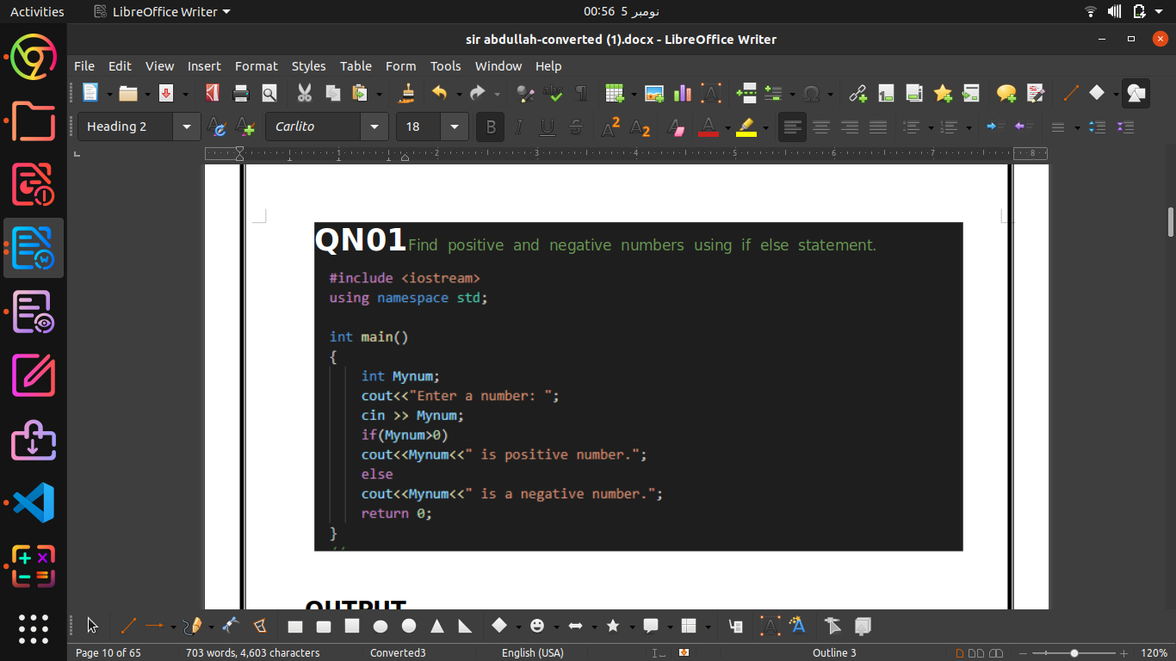

**Output:-**

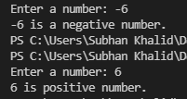

**Q2:**

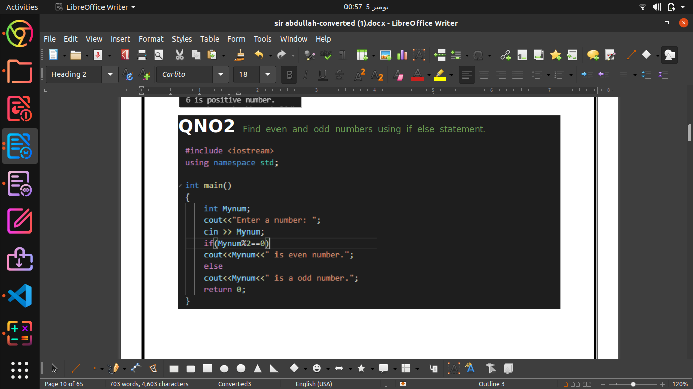

**Output:-**

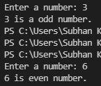

**Q No 3:-**

**QNO3**Find leap year using if else statement.Leap year Hints: common year has 365 days (feb 28 days) year%4==0 and year % 400 == 0leap year not year % 100 != 0 Leap year has 366 days (feb 29 days)

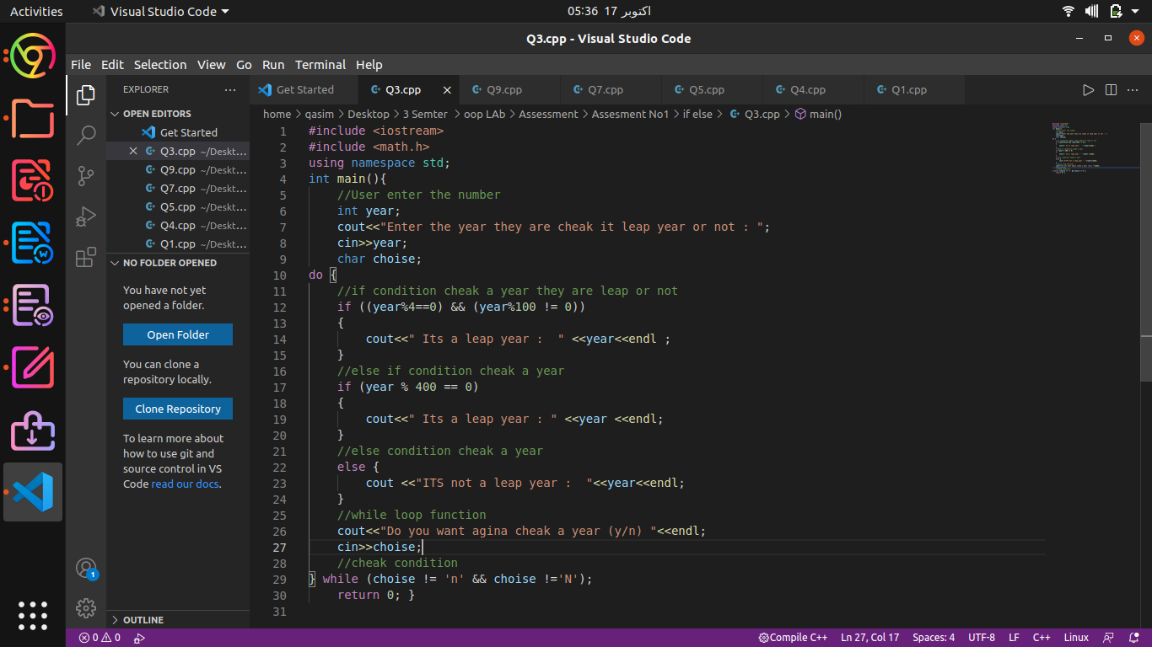

**OUTPUT**

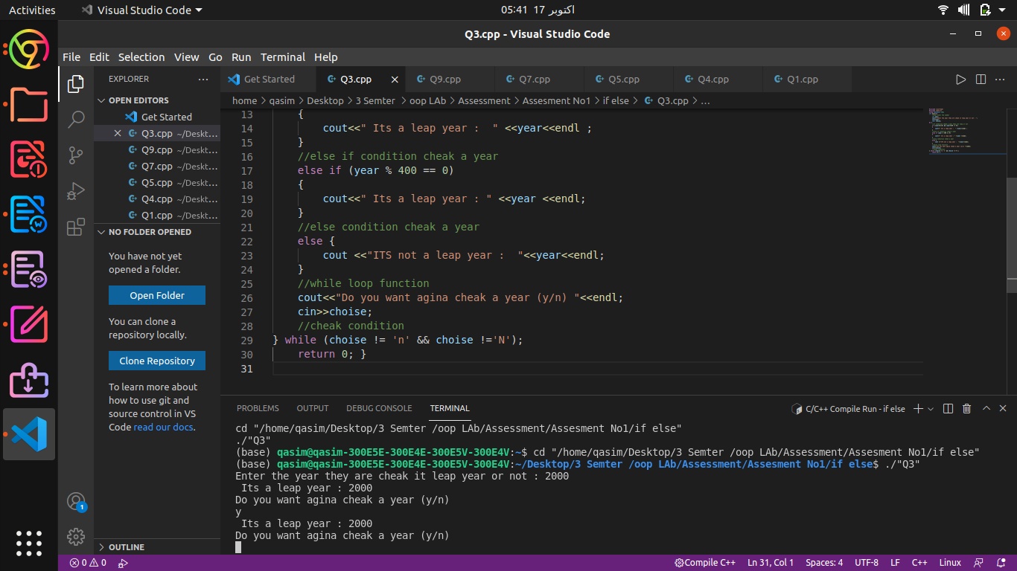

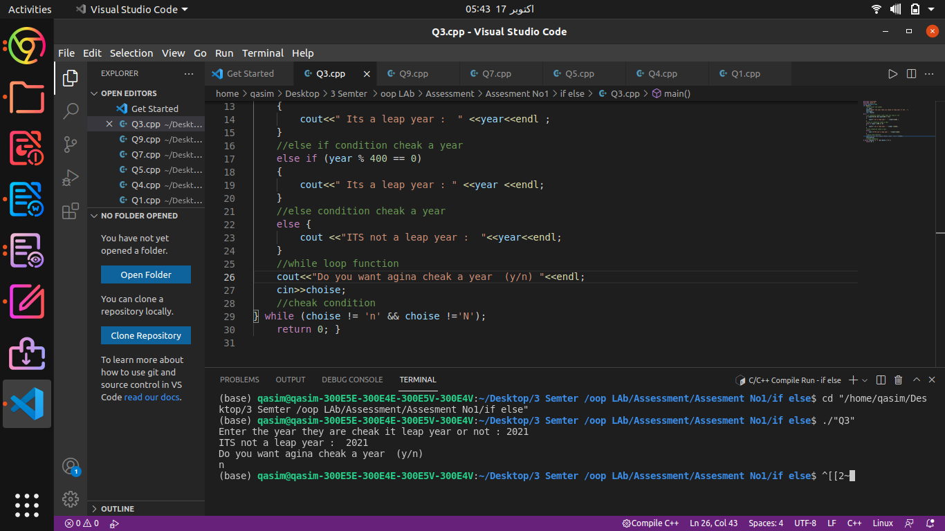Q.No 4:

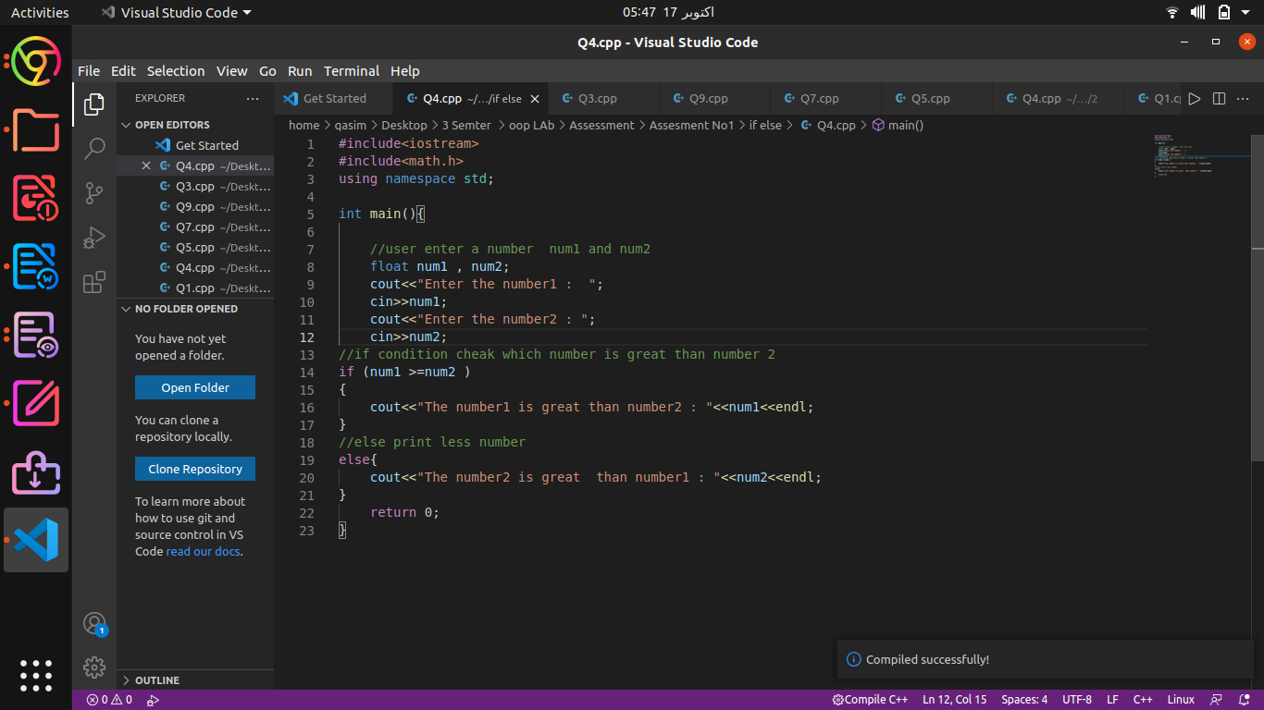

**Output :**

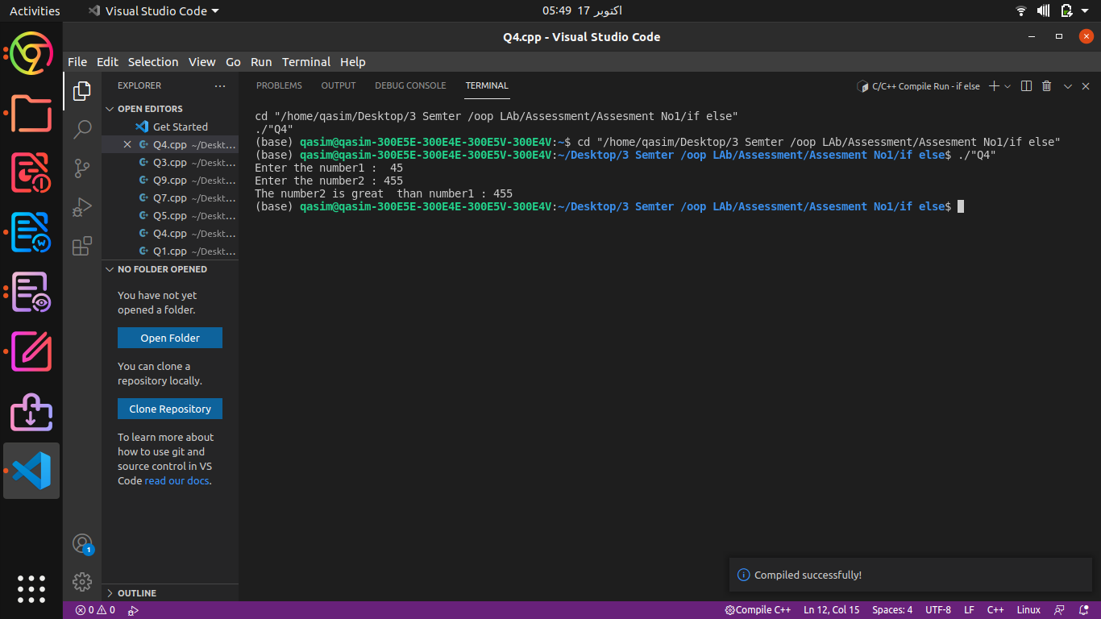

**If-else-if else**

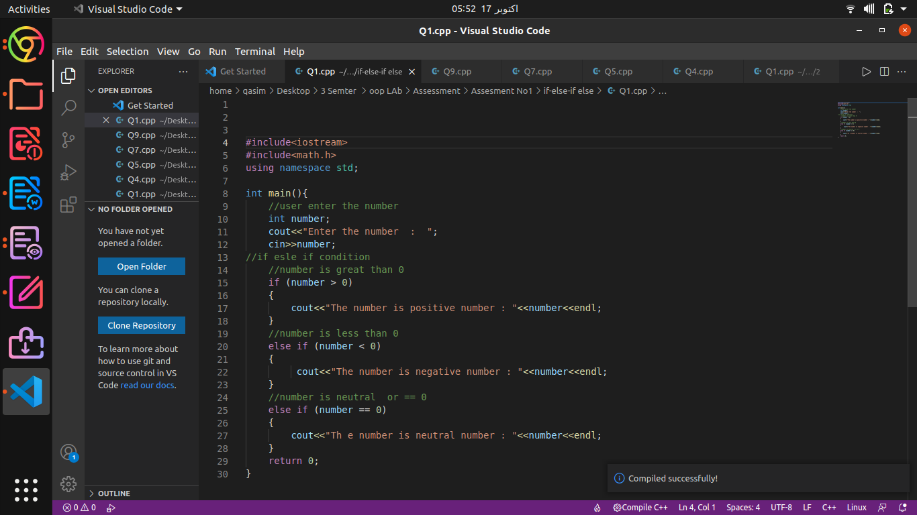

**QNO1** Find positive, negative and neutral numbers using if-else-if else.

**OUTPUT**

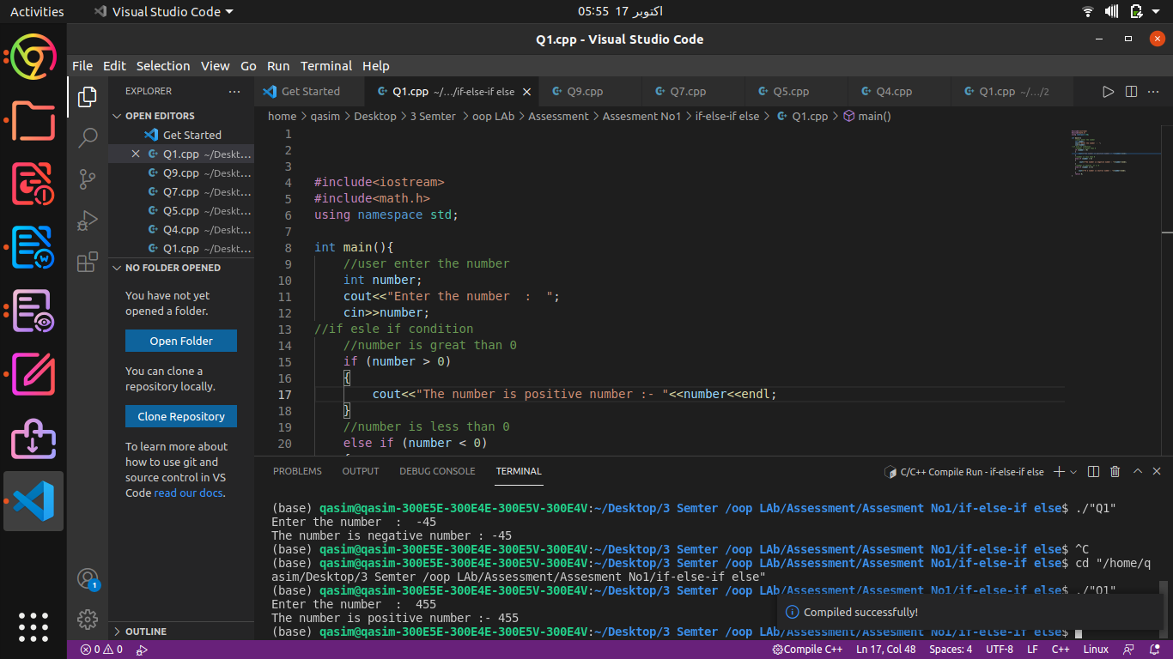

**QNO2 : Take value of temperature from user and find status of weather accordingly.**

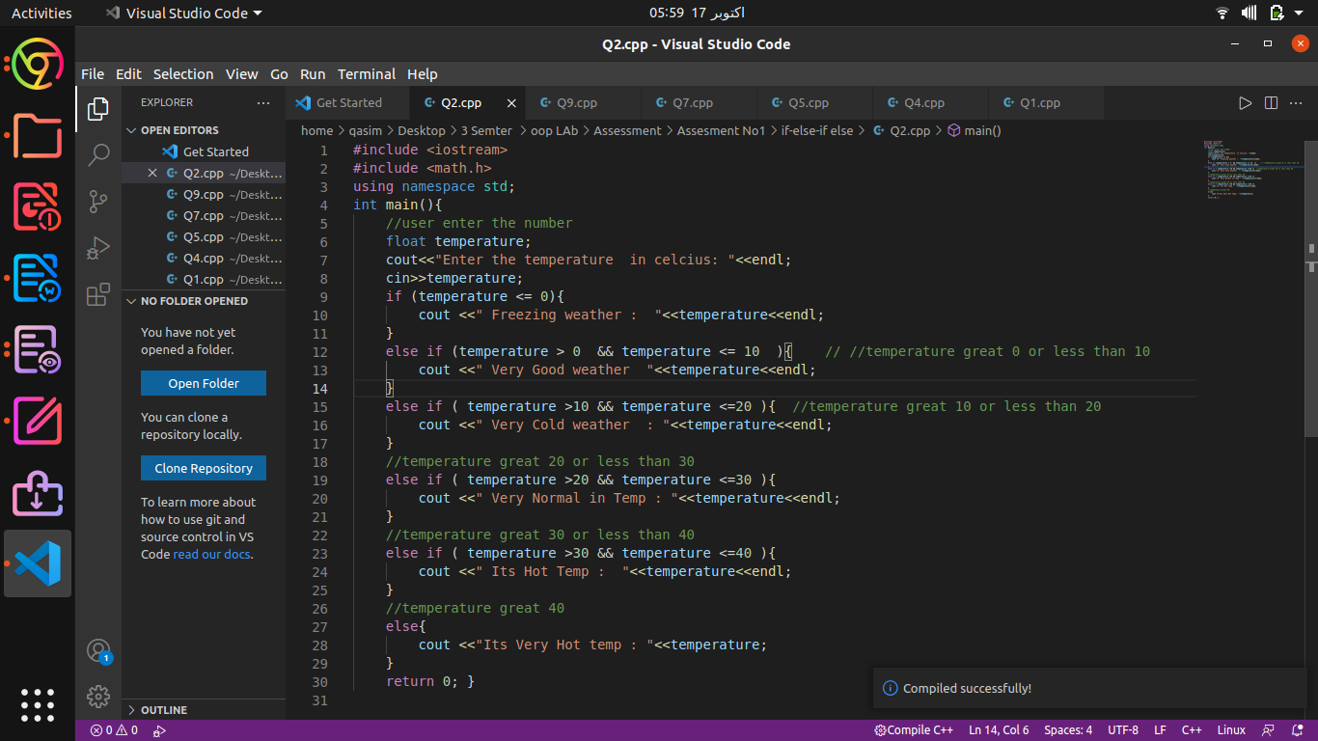

**OUTPUT**

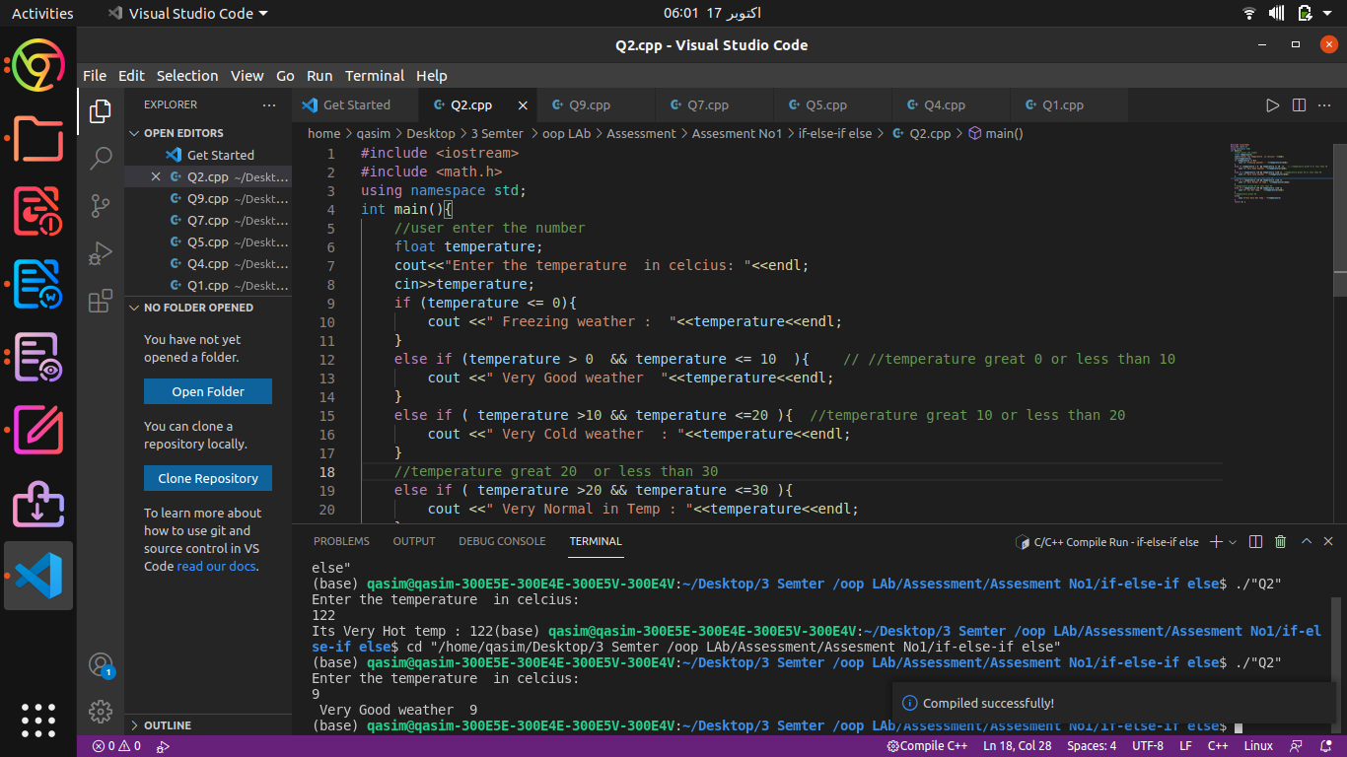

**Q.No 03:Take value of percentage from user and find grades based on percentage value.**

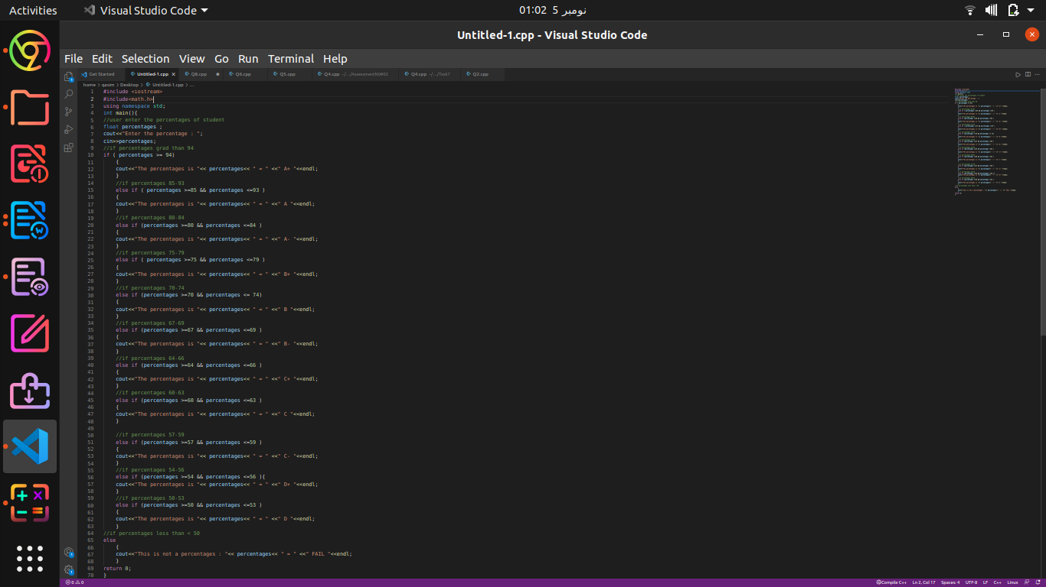

**Output:-**

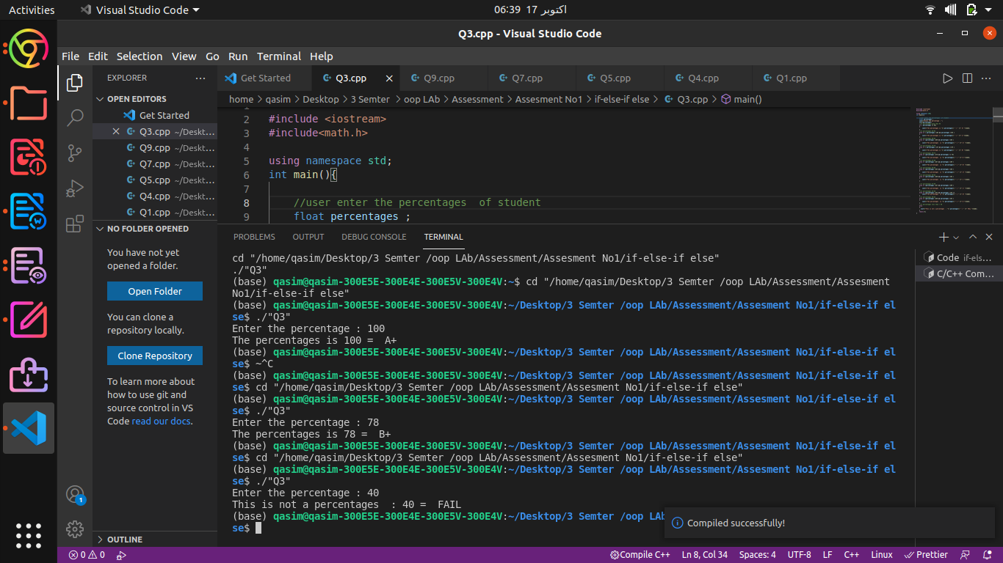

**The code was too long sir:**

**QNO4 : Make a calculator using if-else-if else statement which perform the addition, subtraction, multiplication, division and remainder operations. Take values and operator from user on runtime.**

**#include <iostream>**

#include <math.h>

using namespace std;

int main(){

//int a cin for number and reusult storge a ans

int first_number , second_number ,result;

//char operation (+ , - ,/ ,*)

char operater, choice;

// using a do while loop for a function

do

{

cout<<"Enter the first number = "; //user enter the first input in user

cin>>first_number;

cout<<"Enter the second number = "; //user enter the second input

cin>>second_number;

cout<<"Enter the operation (+ , - ,/ ,* ,%) = ";//user enter the operation that can work funcion

cin>>operater;

if (operater == '+'){ //if condition used the operation == to + the iner fuction exction

result=first_number + second_number; //first_number and second number add and storge in

cout<<"The result of Addition is : "<<first_number<<" + "<<second_number << " = "<<result<<endl;

}

else if (operater == '-'){

//first_number subraction second_number and storge in result

result = first_number - second_number;

cout<<"The result of Subraction is : "<<first_number<<" - "<<second_number << " = " <<result<<endl;

}

else if (operater == '/') //also same conditional operation == / the function can work

{

//if condition for the second number == 0 the function was not work other wiashe alse condition

if (second_number == 0)

{

cout<<"The number was not divided by 0 = " <<second_number<<endl;

}

// if condition flase they ex in alse condition

else{

//first_number divide second_number and storge in result

result = first_number / second_number;

cout<<"The result of divide is : "<<first_number<<" / "<<second_number << " = " <<result<<endl;

} }

////also same conditional operation == * the function can work

else if (operater == '*') {

//first_number multiplication second_number and storge in result

result= first_number * second_number;

cout<<"The result of multiplication is : "<<first_number<<" * "<<second_number << " = "<<result<<endl;

}

////also same conditional operation == * the function can work

else if (operater == '%')

{

result= first_number % second_number;

cout<<"The result of multiplication is : "<<first_number<<" % "<<second_number << " = "<<result<<endl;

}

//else the operation was worrge , thay can no work any fuction

else {

//cout the worry operation in output

cout<<"You get a worry input in operation in fuctoin : " <<operater<<endl;

cout<<"agina try = "<<operater<<endl; }

cout << "Do you want to do another calculation? (y/n)> ";

//enter you choose please

cin >> choice;

//while you choose

}while(choice != 'n' && choice != 'N');

return 0;

}

**Out put:**

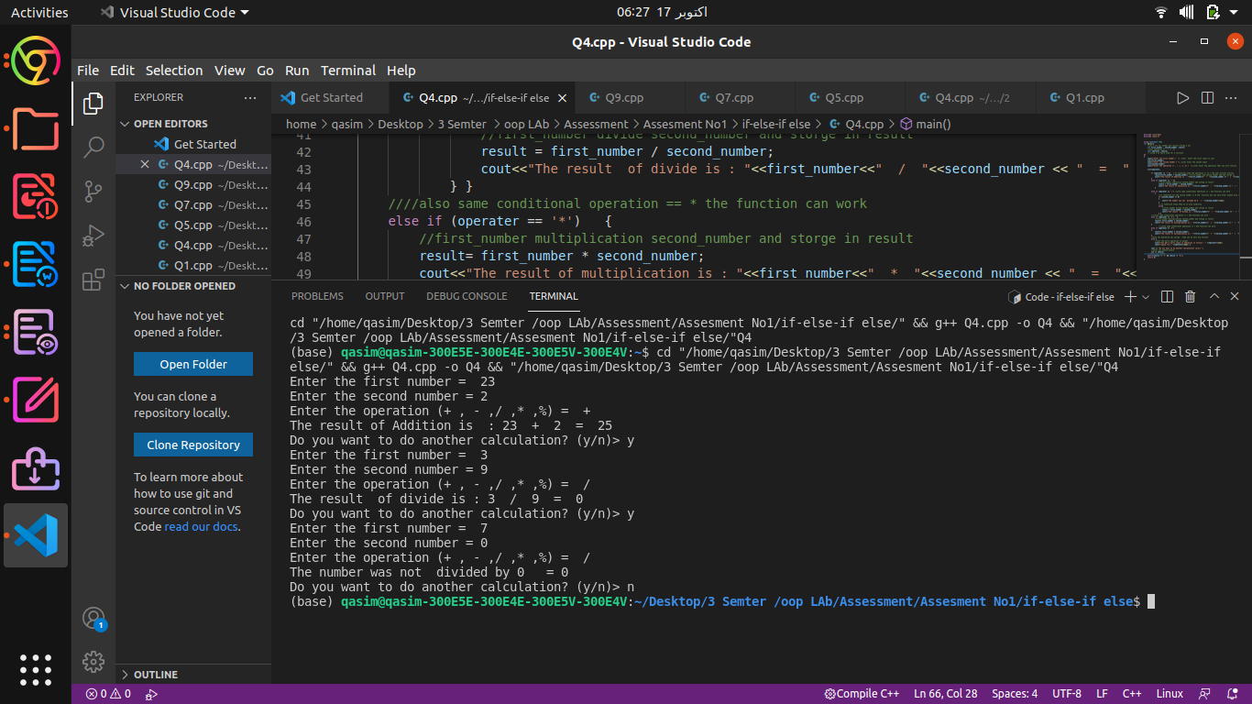

**Conditional Operator (?:)**

**QNO1**

Write a C++ program which will get two numbers from user and find large number between them using conditional operator

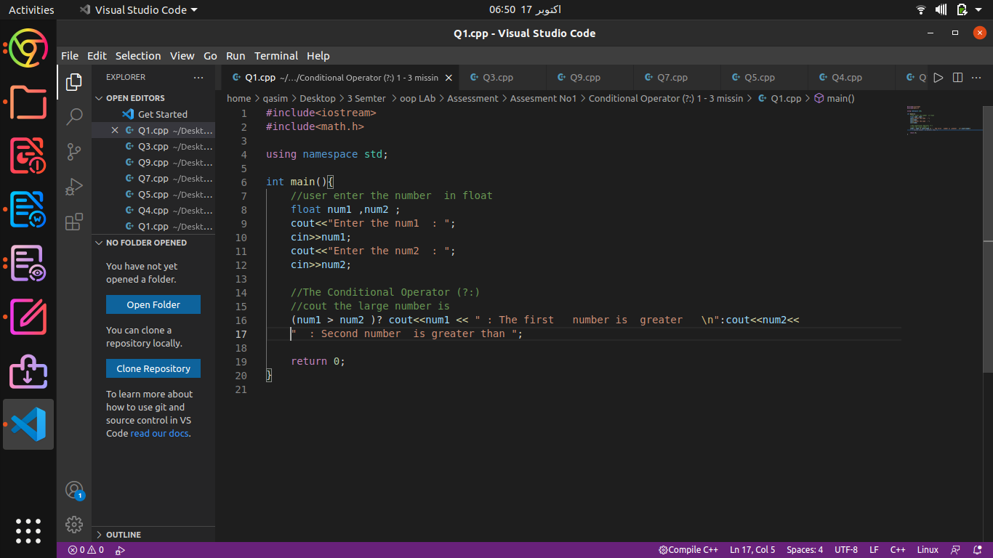

**Output :**

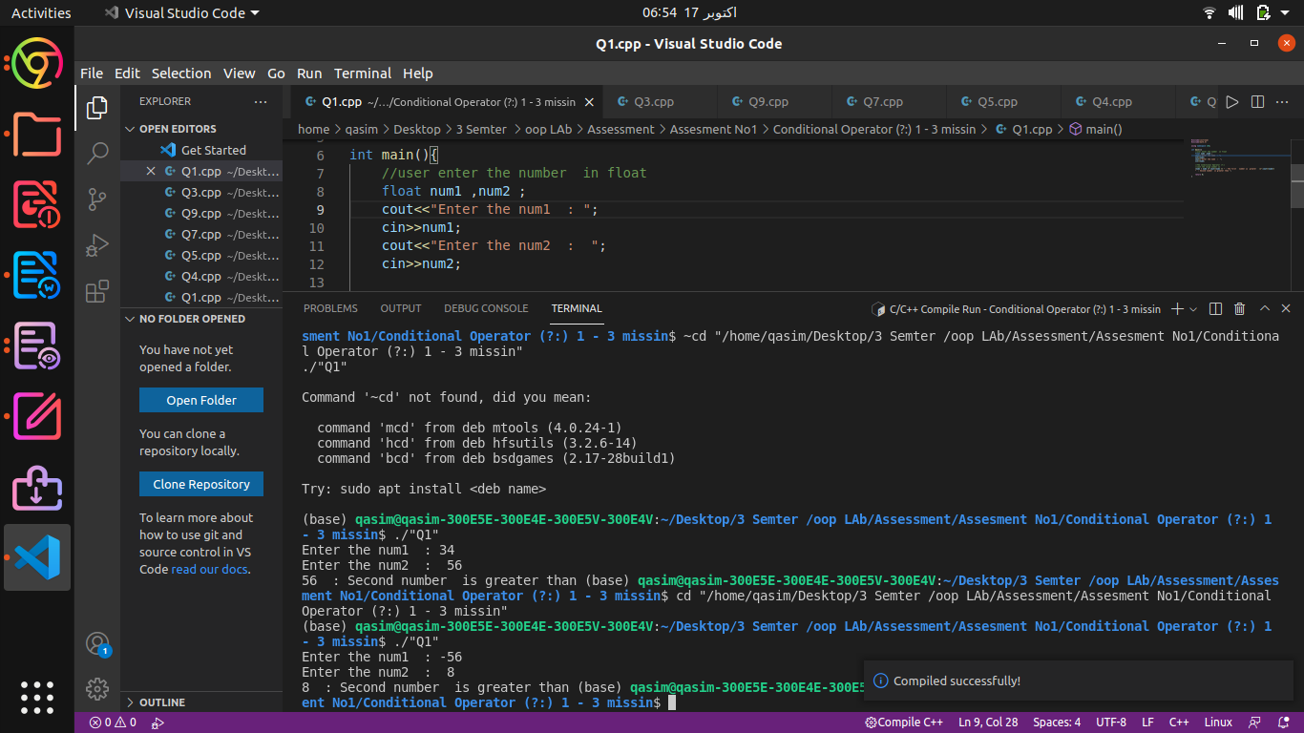

**QNO2: Find positive and negative numbers using conditional operator.**

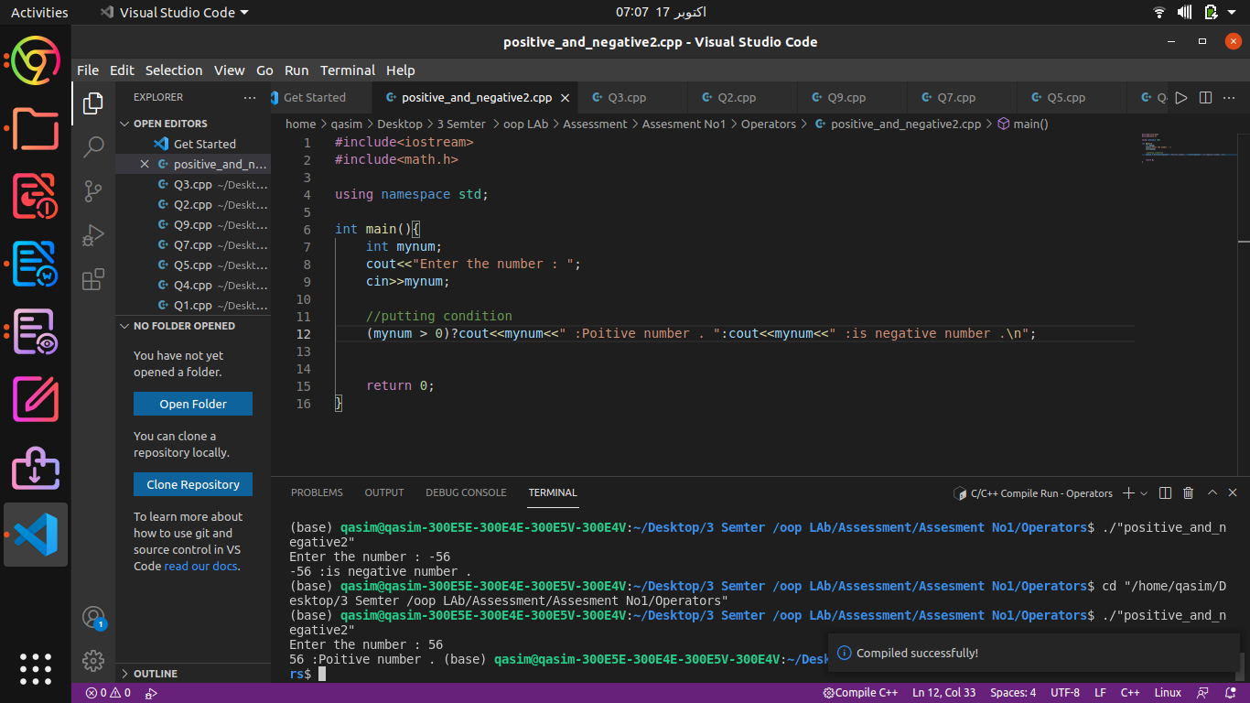

**Output :**



**Q NO3: Find even and odd numbers using conditional operator.**

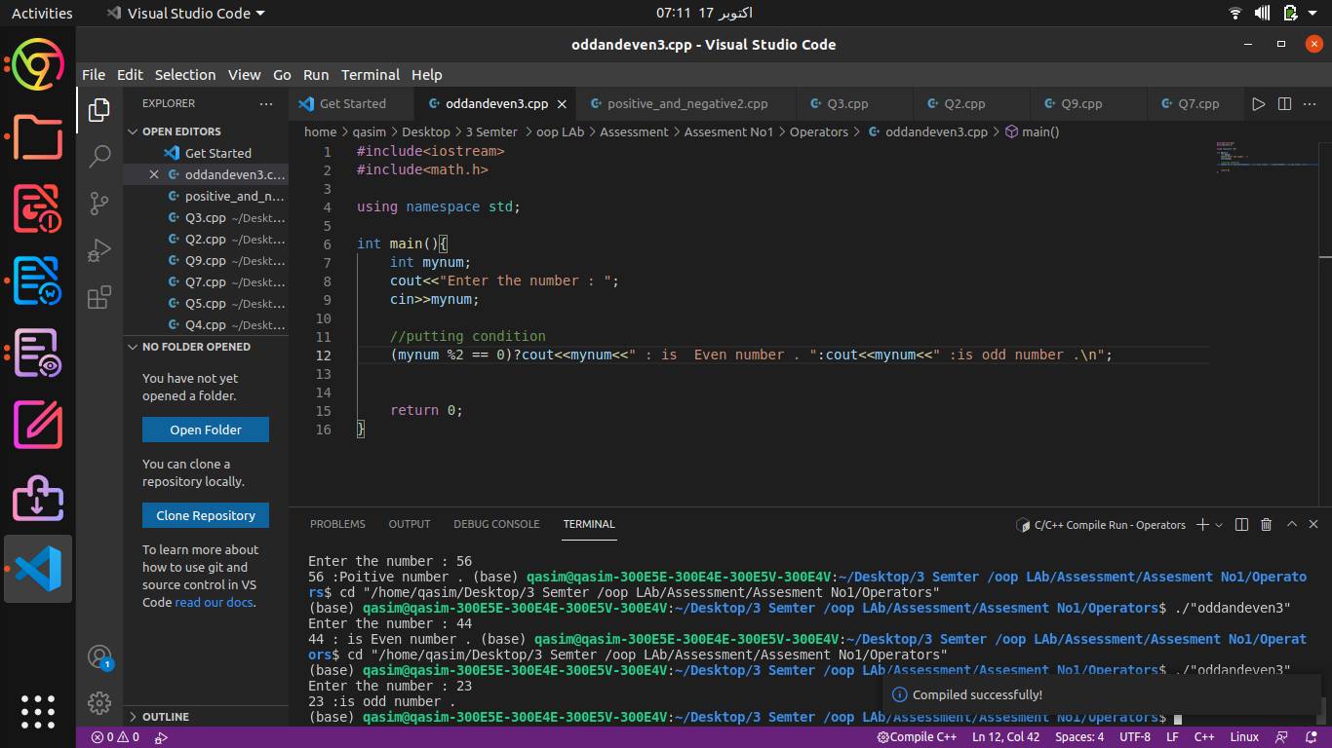

**The code was too long sir:**

**Switch Statement**

**Q.No1: Make a C++ calculator using switch statement which perform the following addition,subtraction, multiplication, division and remainder value. Take value and operator from user on runtime**.

**#include <iostream>**

#include <math.h>

using namespace std;

int main(){

//int a cin for number and reusult storge a ans

int first_number , second_number ,result;

//char operation (+ , - ,/ ,*)

char operater, choice;

//do while loop

do{

//user enter the first input in user

cout<<"Enter the first number = ";

cin>>first_number;

//user enter the second input

cout<<"Enter the second number = ";

cin>>second_number;

//user enter the operation that can work funcion

cout<<"Enter the operation (+ , - ,/ ,*, % ) = ";

cin>>operater;

//switch finction start

switch (operater)

{

//case of Add

case '+':

//Add a number a storge in result

result=first_number + second_number;

cout<<"The result of Addition is : "<<first_number<<" + "<<second_number << " = " <<result<<endl;

break;

//Subraction operation

case '-':

//Subraction a number a storge in result

result = first_number - second_number;

cout<<"The result of Subraction is : "<<first_number<<" - "<<second_number << " = " <<result<<endl;

break;

//divide operation

case '/':

//divide a number a storge in result

result = first_number / second_number;

cout<<"The result of divide is : "<<first_number<<" / "<<second_number << " = " <<result<<endl;

break ;

// multiplication operation

case '*':

//multiplication a number a storge in result

result= first_number * second_number;

cout<<"The result of multiplication is : "<<first_number<<" * "<<second_number << " = " <<result<<endl;

break ;

// remainder operation

case '%':

//remainder a number a storge in result

result= first_number % second_number;

cout<<"The result ofremainder is : "<<first_number<<" % "<<second_number << " = " <<result<<endl;

break ;

//default mean the all case is flase after run default

default:

cout<<"You get a worry input in operation in fuctoin : " <<operater<<endl;

cout<<"agina try = "<<operater<<endl;

break;

}

// chosse you are start angin the whole function

cout << "Do you want to do another calculation? (y/n)> ";

//enter you choice

cin >> choice;

//using a while loop

}while(choice != 'n' && choice != 'N');

return 0;

}

**Out put:**

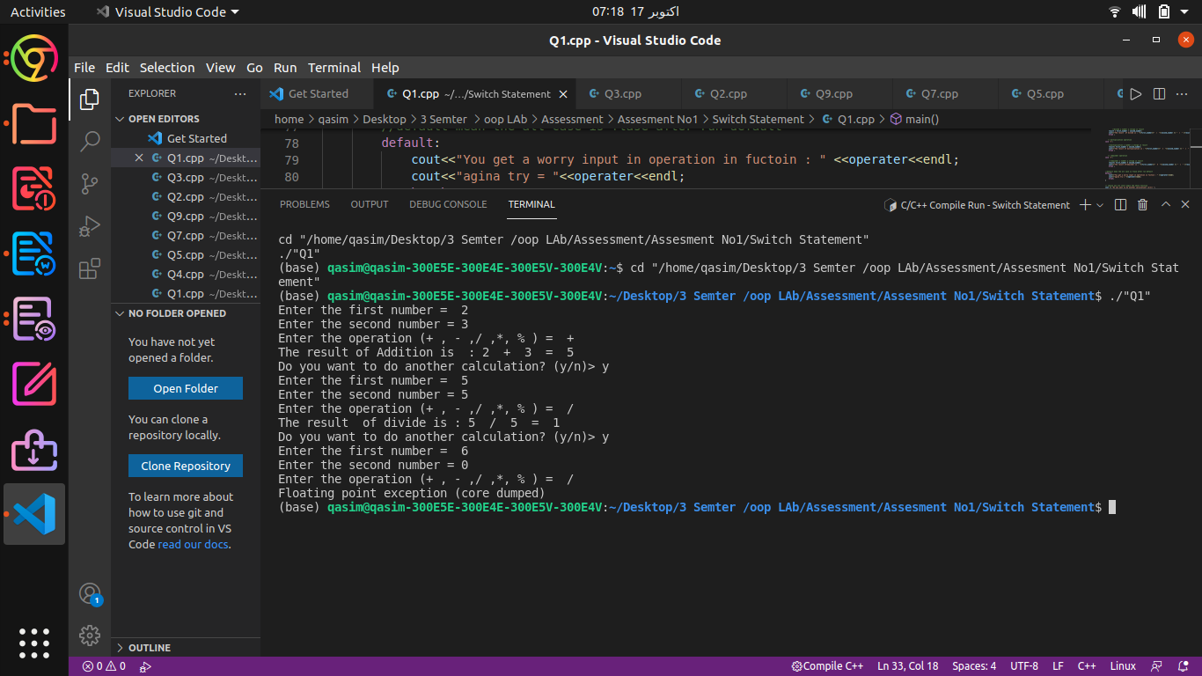

**Q No2: Write a C++ program using switch statement which get month name from user and display month number accordingly.**

#include <iostream>

#include <strings.h>

using namespace std;

int main(){

//user enter the name

int month_name;

cout <<"Enter the mouth (1-12) : ";

cin>>month_name;

//switch a program of case

switch (month_name)

{

case 1:

cout<<"The mounth number is : "<<"January "<<endl;

break;

case 2:

cout<<"The month number is : "<<" February "<<endl;

break;

case 3:

cout<<"The month number is : "<<" March "<<endl;

break;

case 4:

cout<<"The month number is : "<<" April "<<endl;

break;

case 5:

cout<<"The month number is : "<<" May "<<endl;

break;

case 6:

cout<<"The month number is : "<<" June "<<endl;

break;

case 7:

cout<<"The month number is : "<<" July "<<endl;

break;

case 8:

cout<<"The month number is : "<<" August "<<endl;

break;

case 9:

cout<<"The month number is : "<<" September "<<endl;

break;

case 10:

cout<<"The month number is : "<<" October "<<endl;

break;

case 11:

cout<<"The month number is : "<<" November "<<endl;

break;

case 12:

cout<<"The month number is : "<<" December "<<endl;

break;

default:

cout<<"You did a wroge name enter in : "<<month_name<<endl;

break;

}

return 0;

}

output:

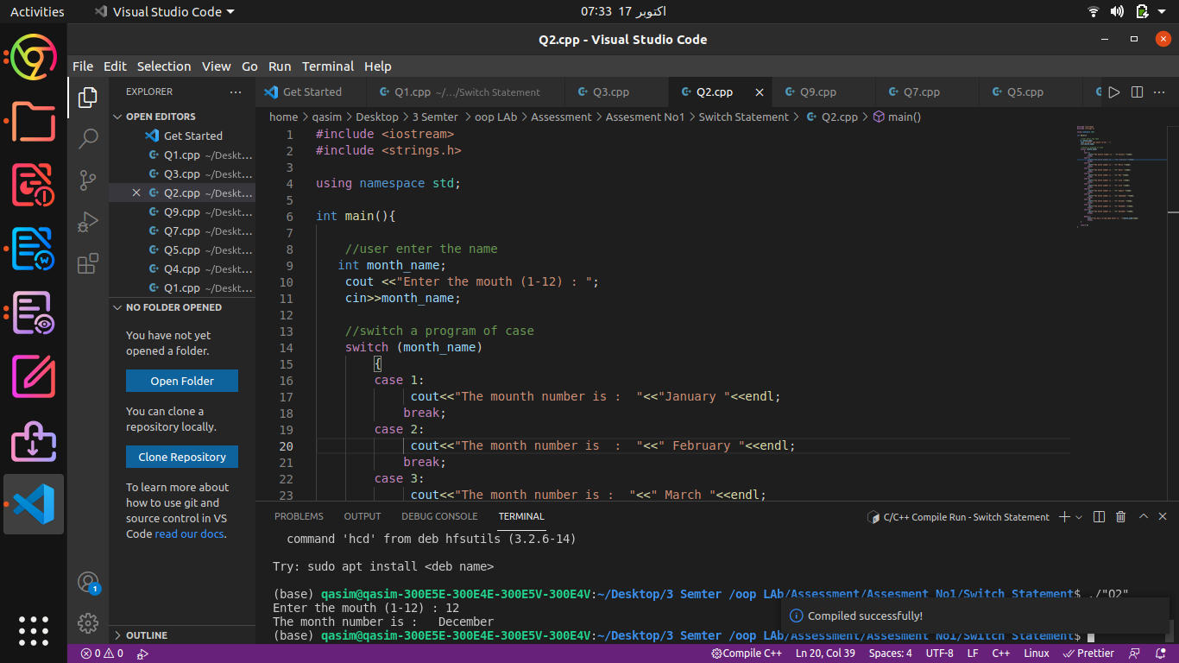

**LOOPS:-**

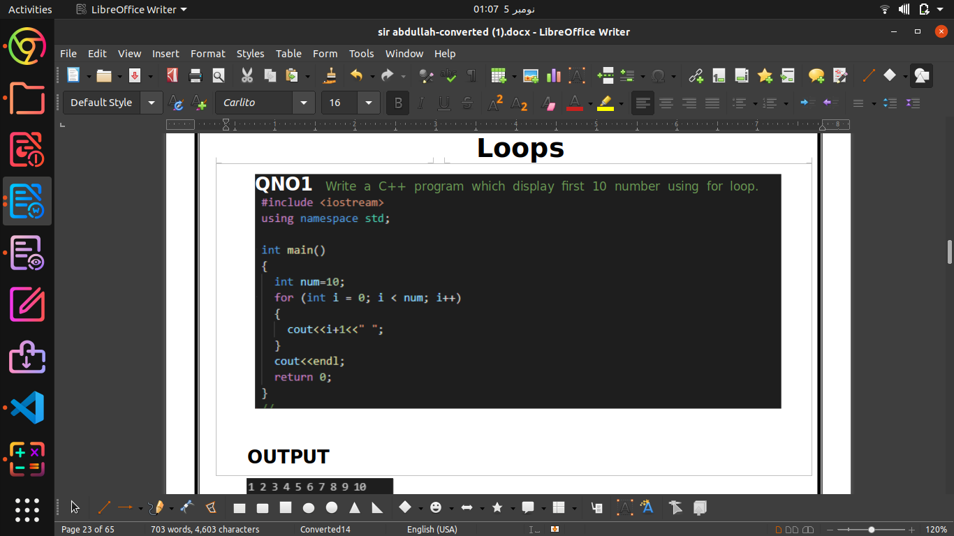

**OutPut:-**



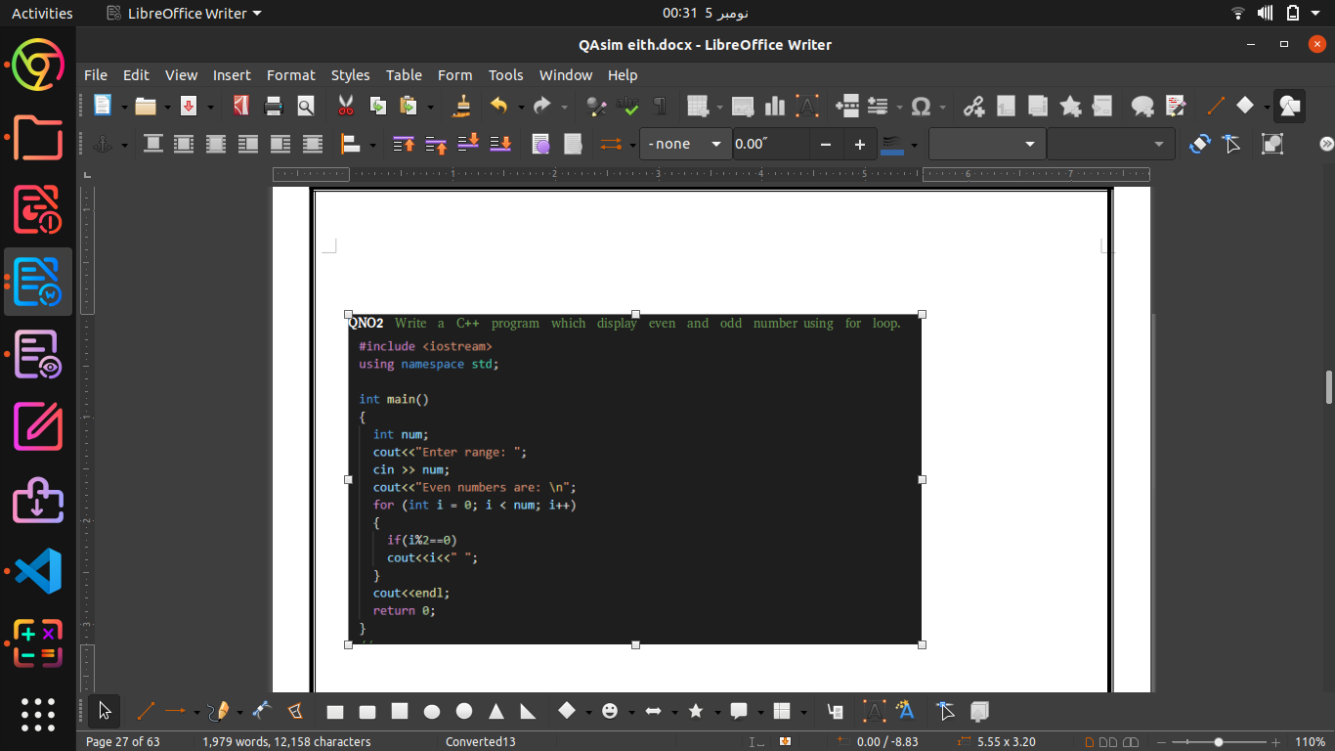

**Output:-**

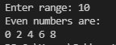

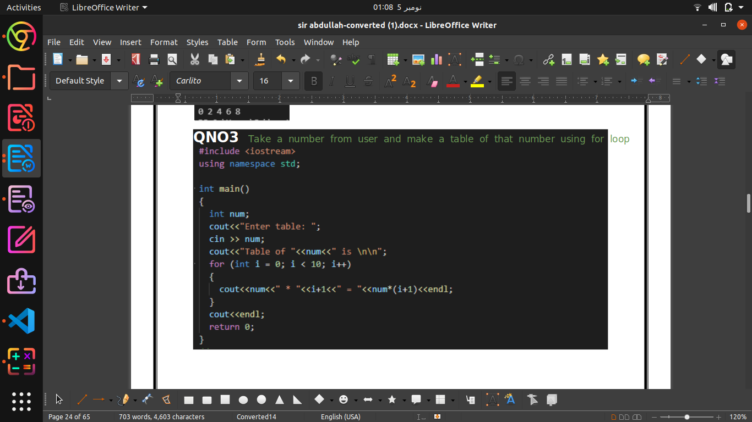

**OUTPUT**

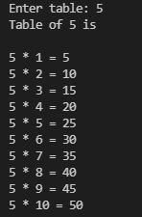

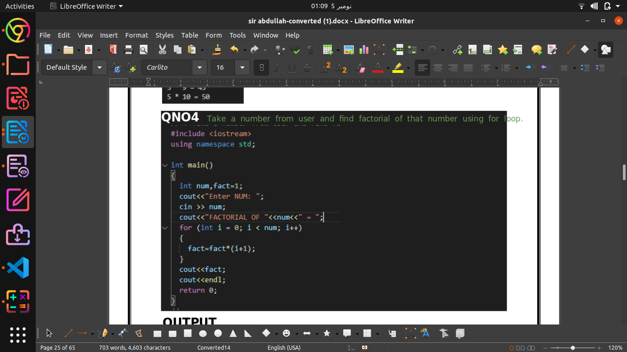

**OUTPUT**



**While loop**

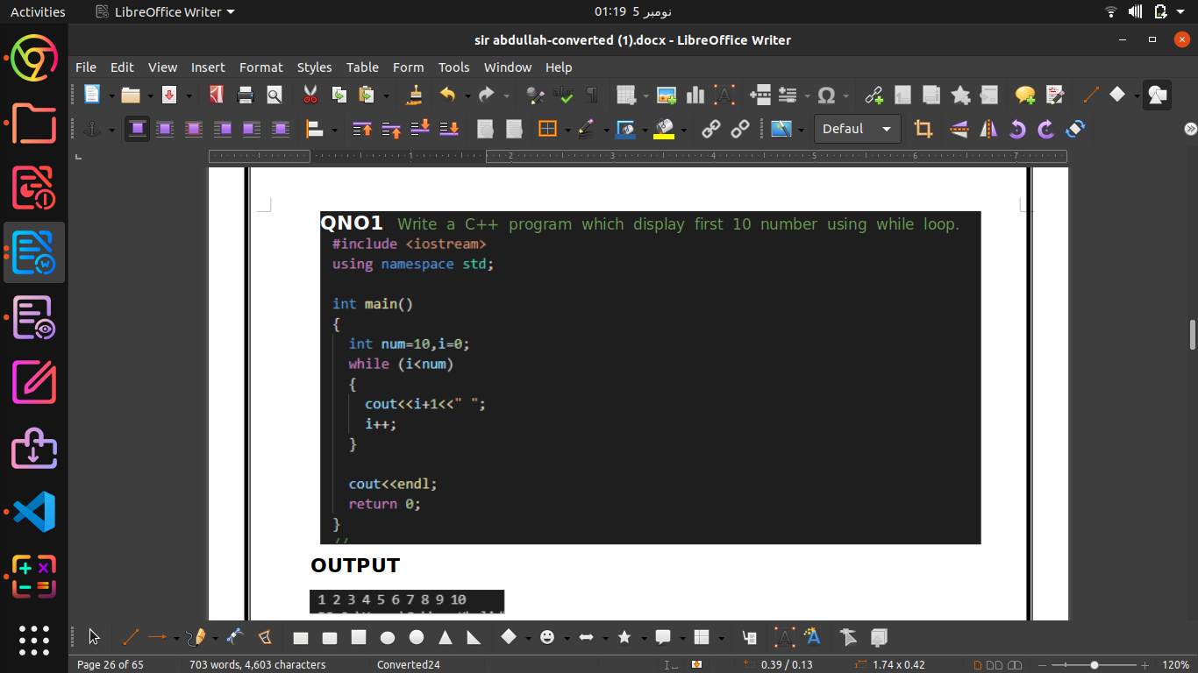

**Output:-**



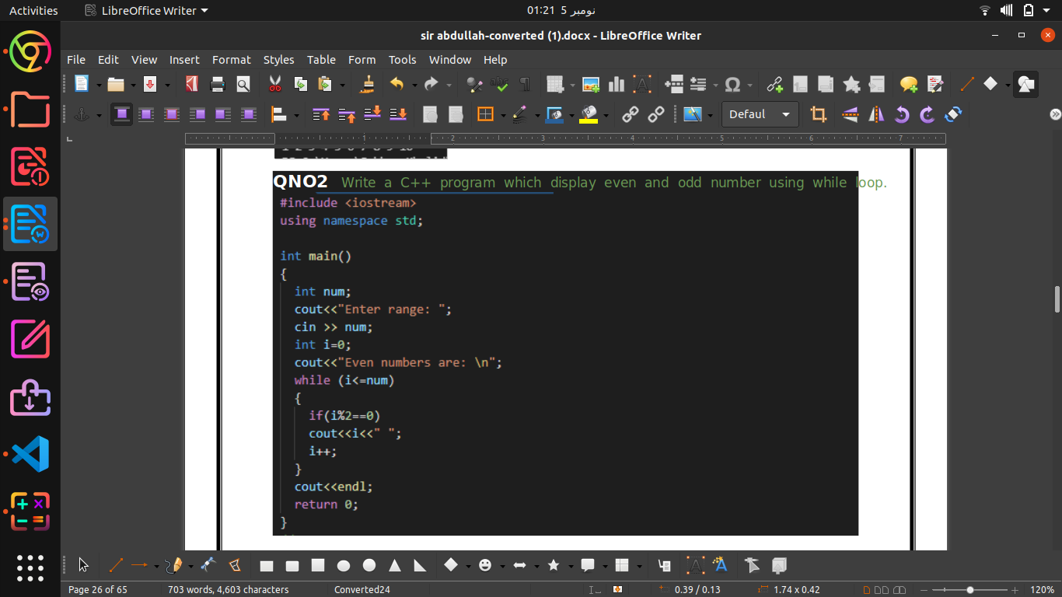

**OUTPUT:-**

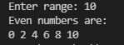

**QNO5** Make a calculator using While loop?

### OUTPUT

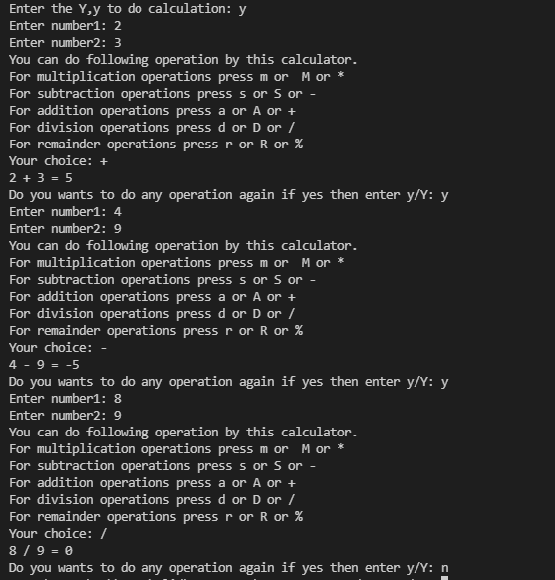

**DO-WHILE-LOOP**

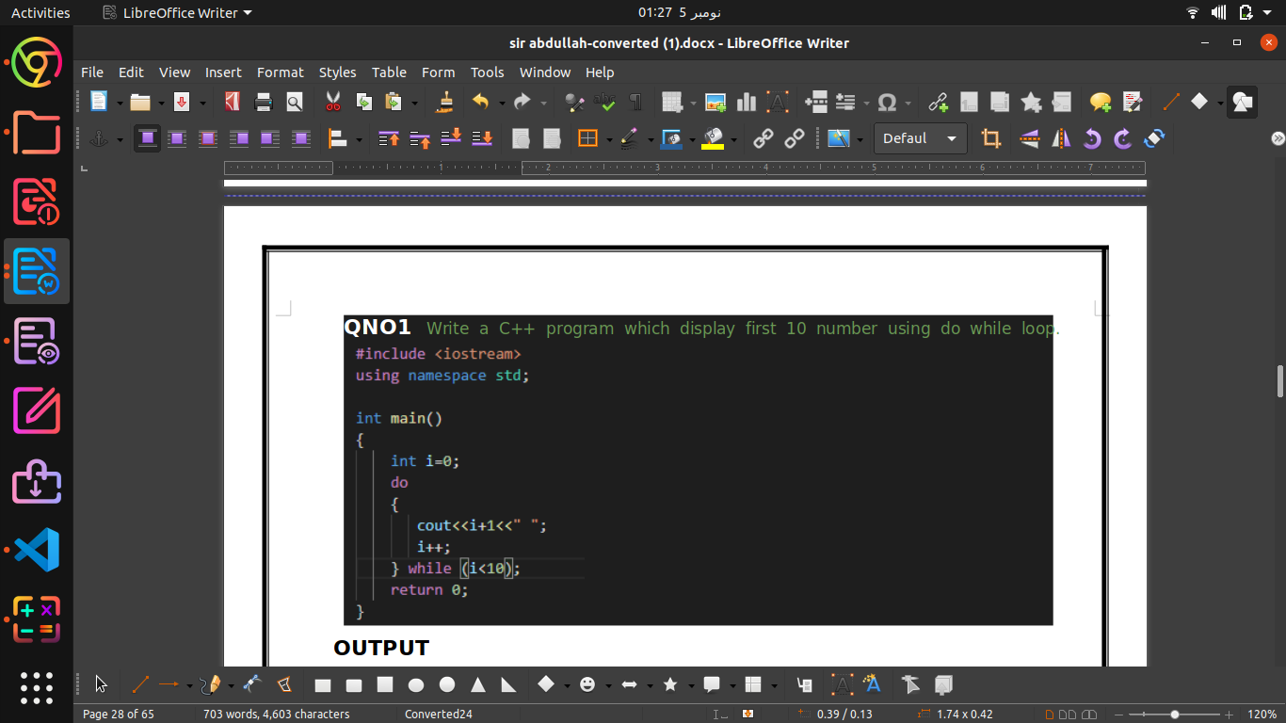

**Output:-**



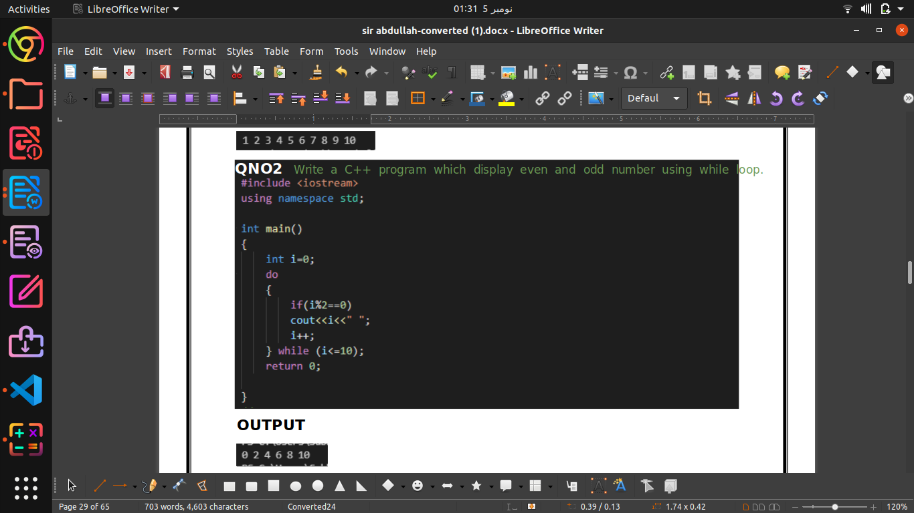

Output:-



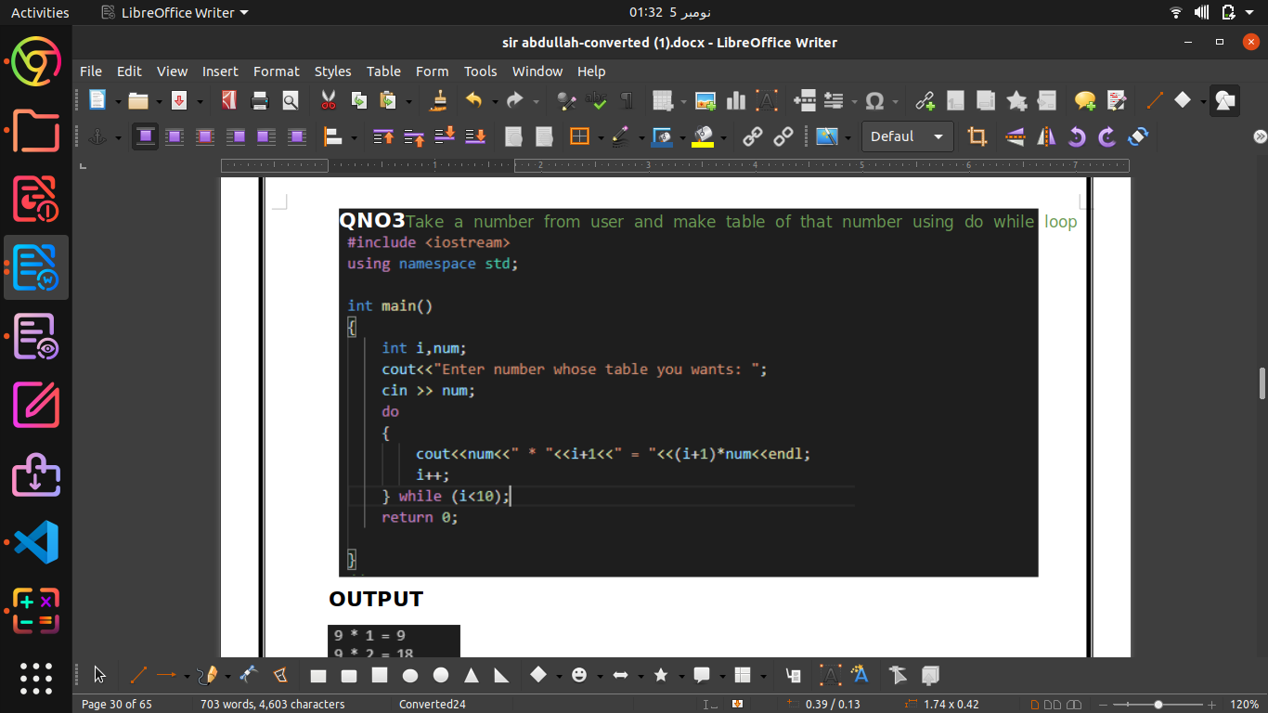

**OUTPUT**

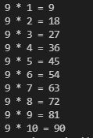

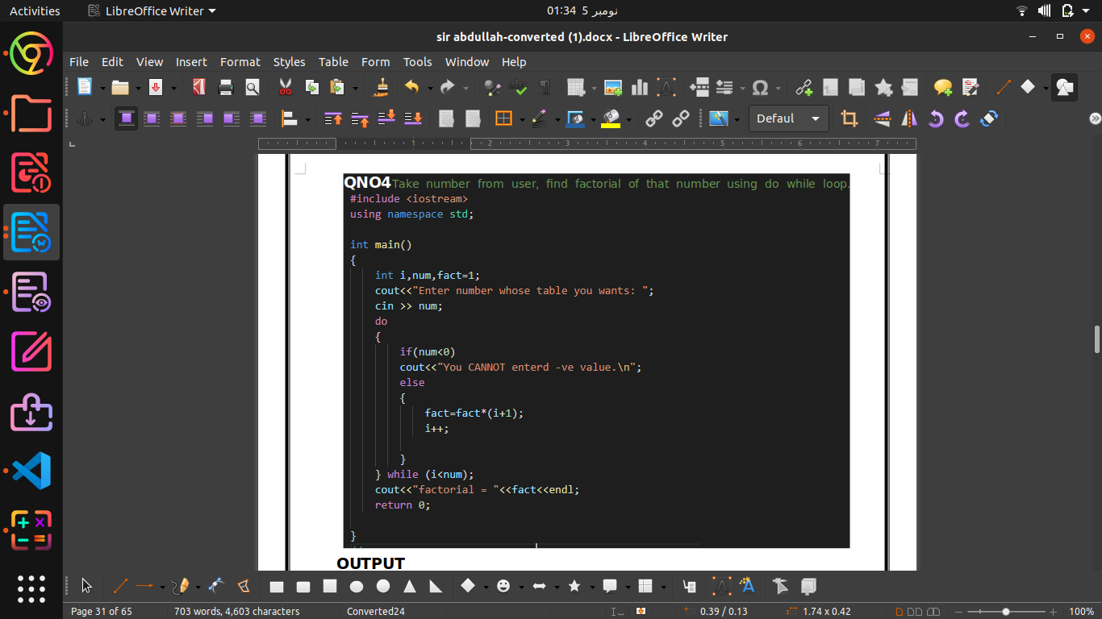

**Output:-**

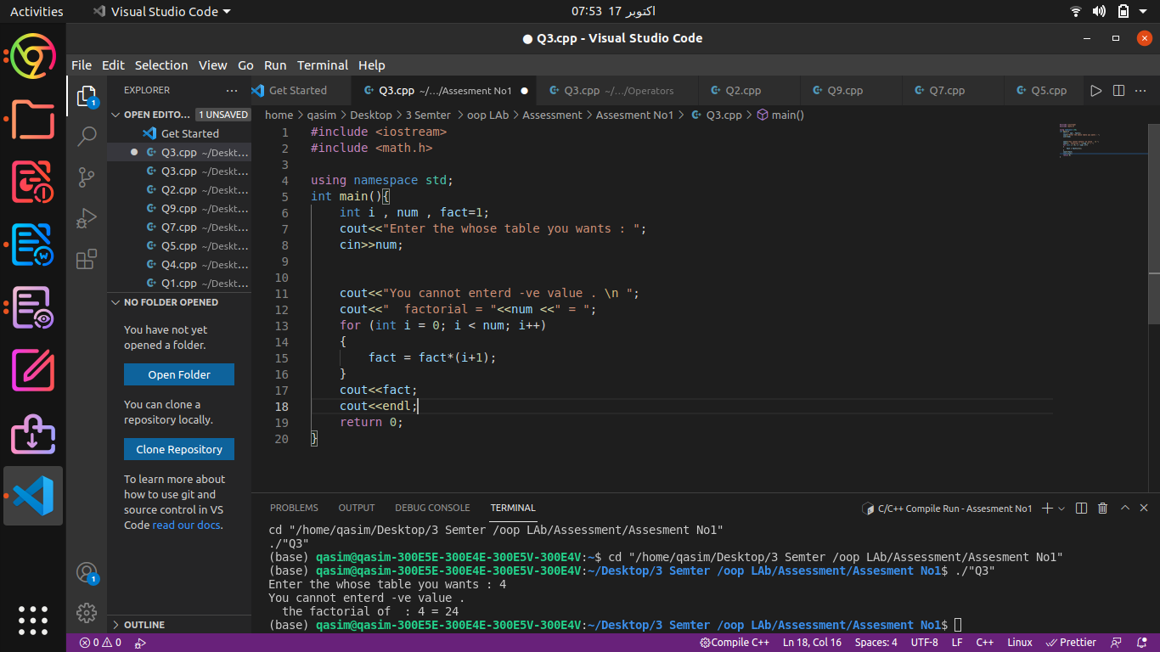

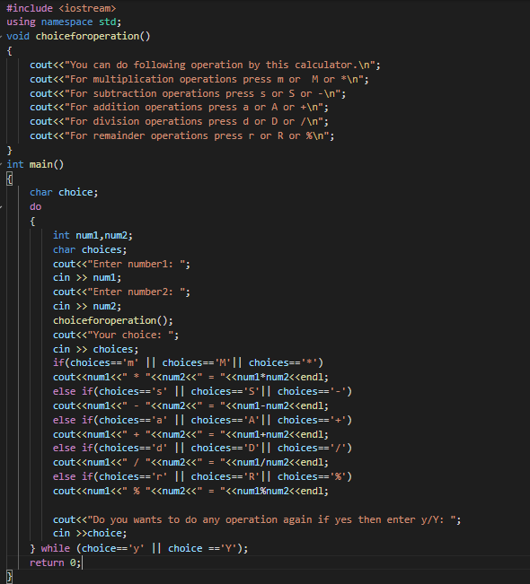

**OUTPUT**

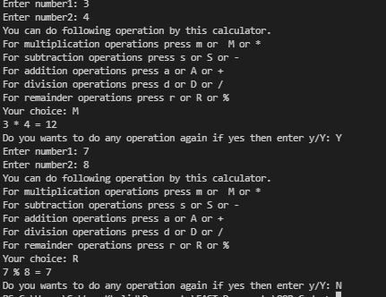

**Nested for loop**

**QNO1** DRAW

* * *

* *

*

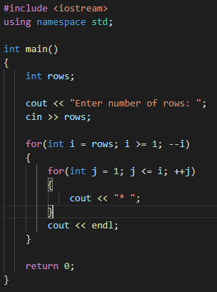

**OUTPUT**

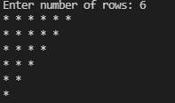

|  |  |
| --- | --- |
| **QNO2** DRAW | |
| 1 | 2 3 4 |
| 1 | 2 3 |
| 1 | 2 |
| 1 |  |

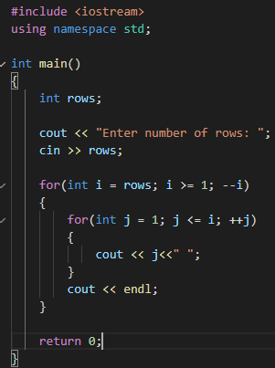

**OUTPUT**

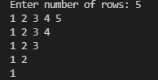

**QNO3** use of "setw" ftn DRAW

*

***

*****

*******

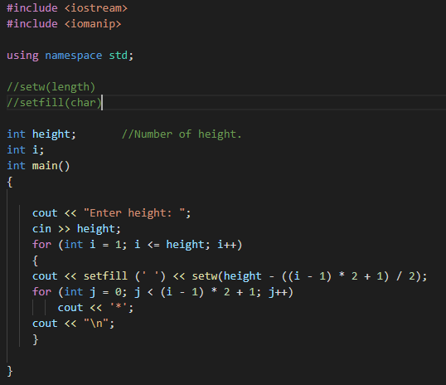

**OUTPUT**

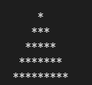

**QNO4** //Q4 DRAW

// ***********

// *********

// *******

// *****

// ***

// *

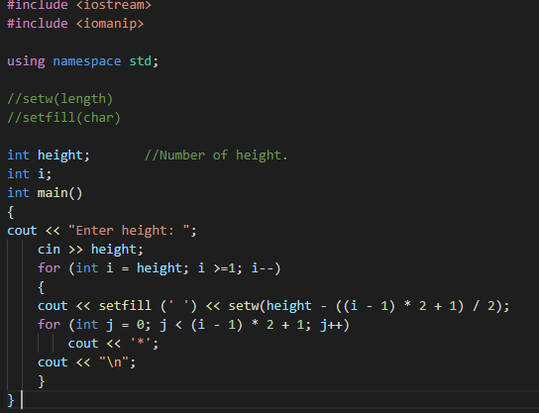

**OUTPUT**

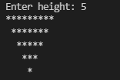

**Arrays 1D** Arrays

**QNO1**

Write a C++ program that will add two single dimensional array elements. Take values from user at runtime.

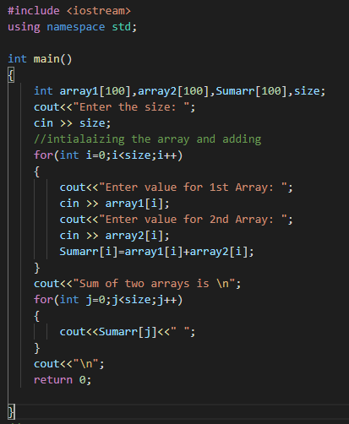

### OUTPUT

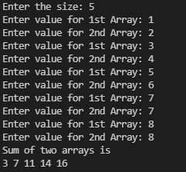

**QNO2**

How to generate random number C++, write a simple C++ program that will generate random number from 1 to 100?

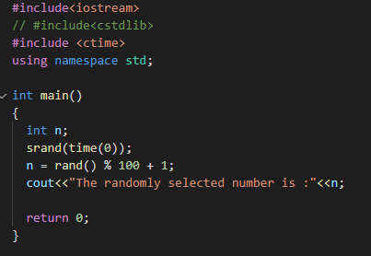

**OUTPUT**

**QNO3**

Write a C++ program that will add two single dimensional arrays elements using random numbers?

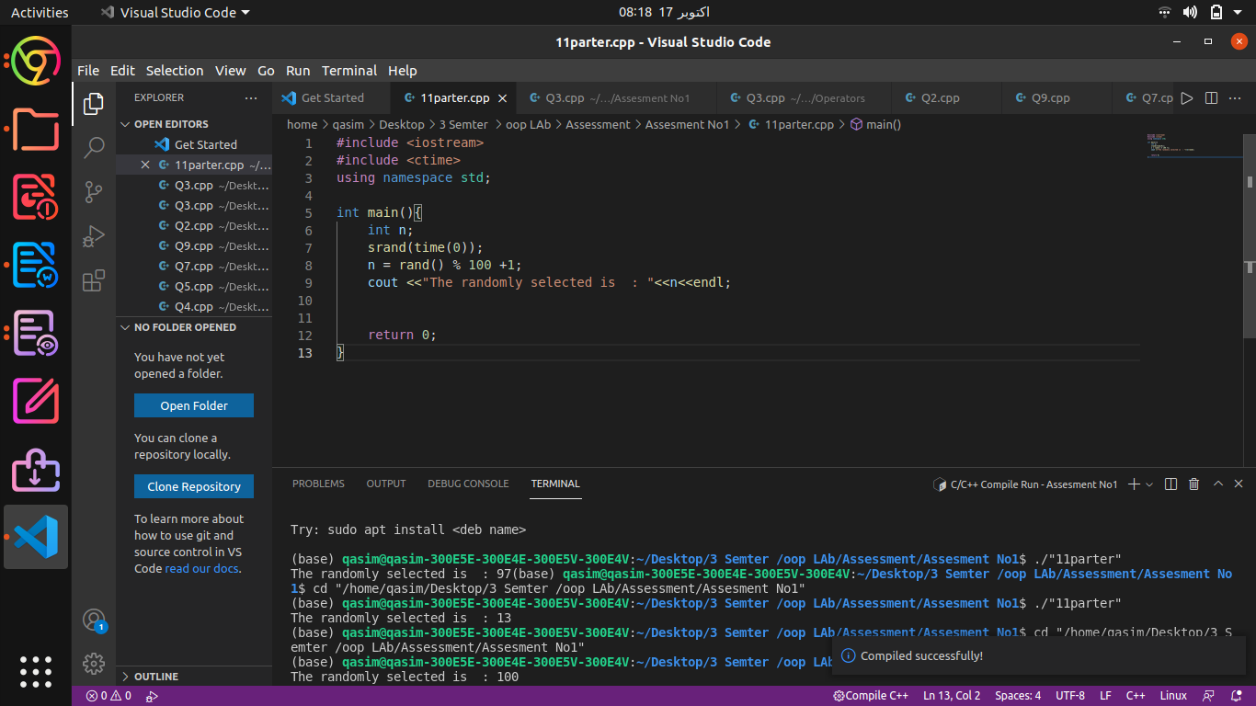

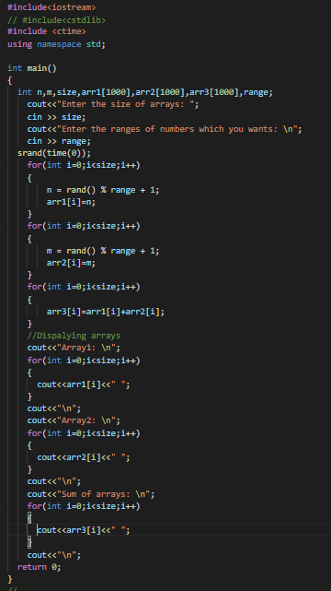

**OUTPUT**

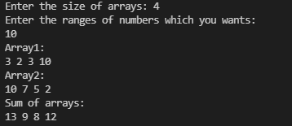

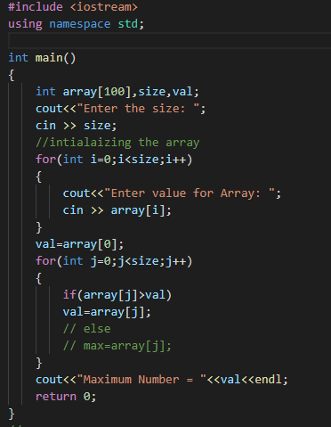

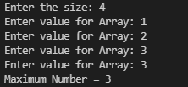**OUTPUT**

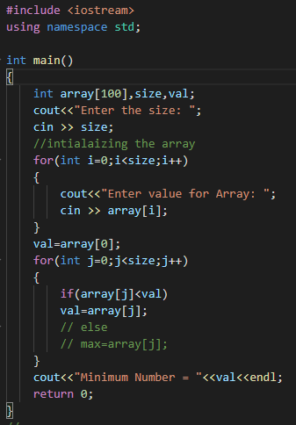

**OUTPUT**

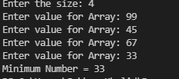

**2D** Arrays

**1. Write a C++ program that will create 2D array using random numbers and then show these values.**

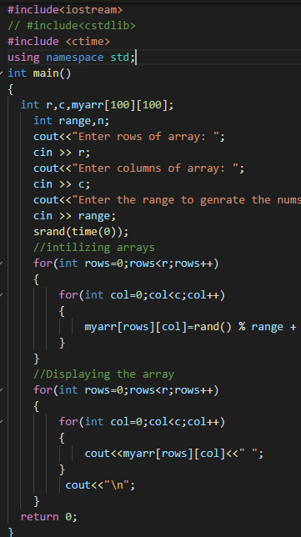

**OUTPUT**

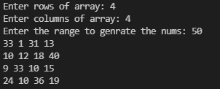**QNO2**

QN0 2: Write a C++ program that will find maximum and minimum number in 2D array. Note array elements must be random values?



**OUTPUT**

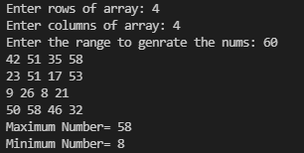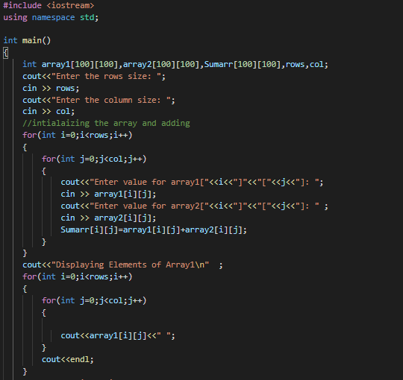

**QNO3**

Write a C++ program that will add two 2D arrays elements. Take values from user runtime. Note display values of 1st, 2nd and their resultant array.Hints: A will

be the 1st array, B will be the 2nd array and C will be resultant array.Note: Fol low Mathematics Matrix Addition Rules

**Question next part is below**

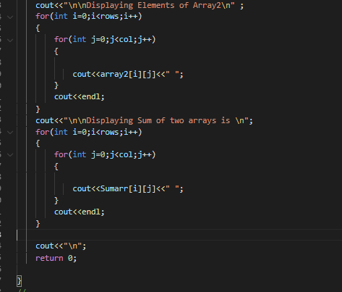

**OUTPUT**

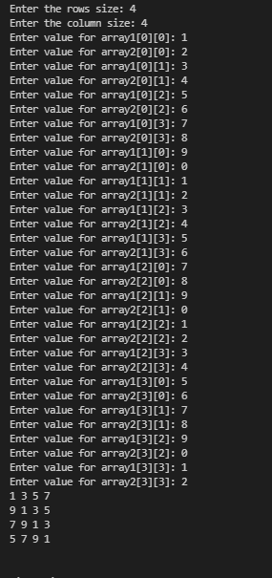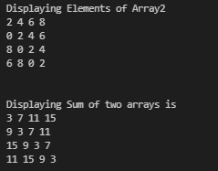

**QNO4**

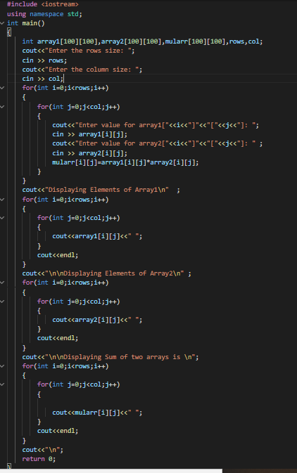

**OUTPUT**

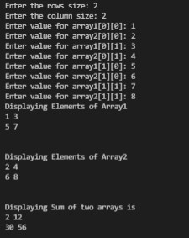

**Functions**

**QNO1:**

function in C++ that will calculate table of a number in C++. Number must be passed from calling function as an argument to function parameters.

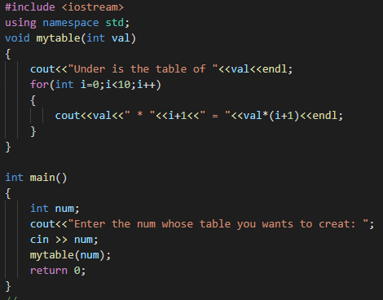

**OUTPUT**

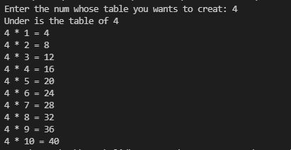

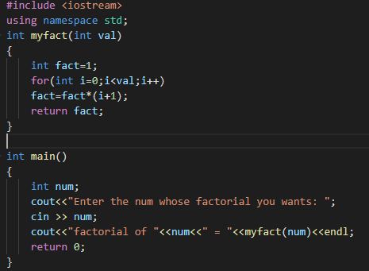

**QNO2**

Write function in C++ that will find factorial of a number. Number must be passed from calling function as an argument to function parameters.

**O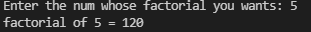UTPUT**

**QNO3**

QNo 3: Update your calculator using functions.

Part A:=

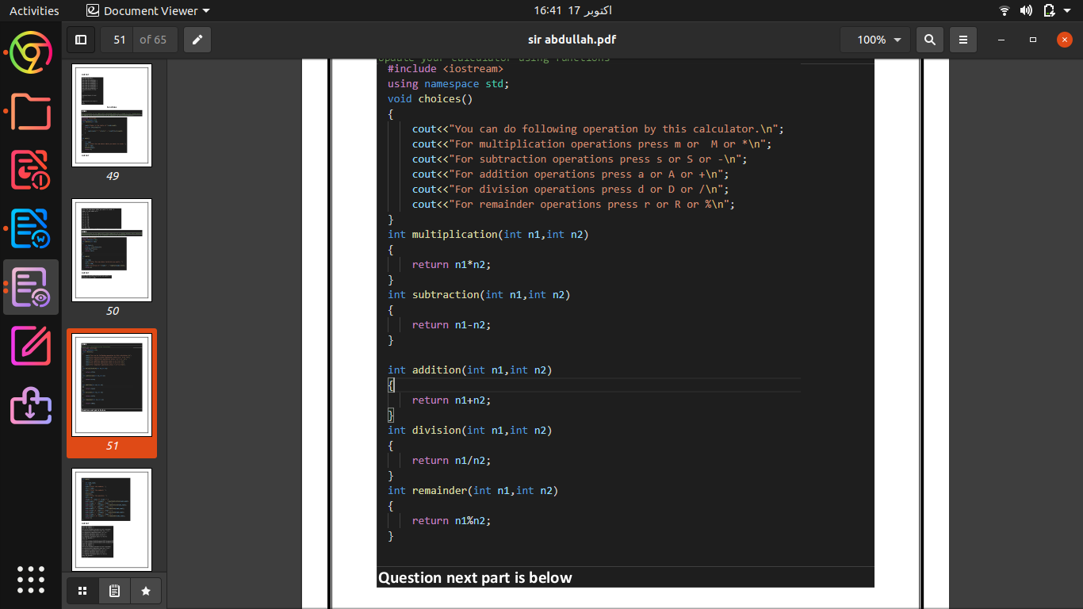

**part B:=**

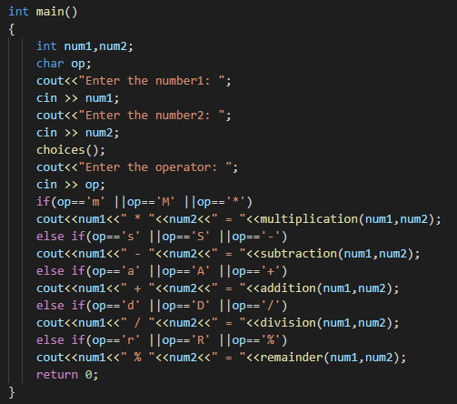

**Output :=**

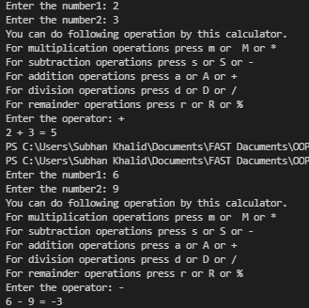

QNo 4: Write user defined function arrayFunction() in C++ which will initialize array by taking values from user at run time and then call this function in main function which will return this array from the calling function to the called function (to the main function) and then show all items of array in main function using loop.

**OUTPUT**

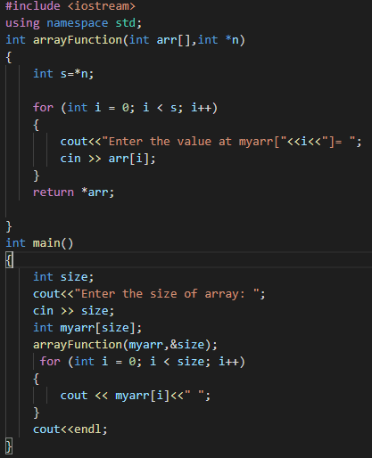

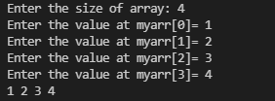

**Qno5** Type checking program

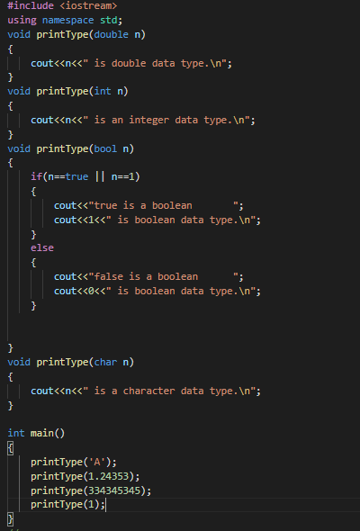

m

**O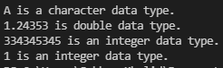UTPUT :=**

**The END**

**Thank you Sir**